D7 Auto Service Center Web-App

Project Documentation Submitted to the Faculty of the

School of Computing and Information Technologies

Asia Pacific College

In Partial Fulfillment of the Requirements for

Systems Analysis and Detailed Design for IT (Information Technology)

MSYADD1

By

Viernes, Andre O. Garcia, Alyssa L.

Alfaras, Dan Michael C. Camino, Francesca Erin R.

Banglagan, Kevin Josef B.

ASIA PACIFIC COLLEGE

Approval Sheet

*D7 Auto Service Center Web-App*

Prepared and submitted by

|  |  |
| --- | --- |
| *Viernes, Andre O.* | *Garcia, Alyssa L.* |
| *Alfaras, Dan Michael C.* | *Camino, Francesca Erin R.*  *Banglagan, Kevin Josef B.* |

In Partial Fulfillment of the Requirements for the Degree of

Bachelor of Science in Information Technology

Examined and Recommended for Acceptance and Approval for

Research/Capstone Presentation

___________________________

Manuel Sebastian S. Sanchez, Adviser

Panelists

___________________________

<Name>, Chairperson

|  |  |
| --- | --- |
| ___________________________ | ___________________________ |
| <Name>, Panel Member | <Name>, Panel Member |

Acceptance and Approved in Partial Fulfillment of the Requirements for the Degree of

Bachelor of Science in Information Technology

___________________________

Rhea-Luz R. Valbuena

Executive Director

School of Computing and Information Technologies

Table of Contents

List of Figures iii

List of Tables iv

I. Introduction 5

1.1 Project Context 5

1.2 Statement of the Problem 5

1.3 Objectives 6

1.4 Significance of the Project 7

1.5 Scope and Limitations 7

II. Review of Related Literature / Systems 9

III. Technical Background 11

3.1 Current System 11

3.2 Proposed System 12

IV. Methodology 15

4.1 Requirements Analysis 18

4.1.1 Product Backlog / User Stories 18

4.1.2 Event Tables 22

4.1.3 Use Case Diagrams 24

4.1.4 Use Case Full Description 25

4.2 Gap Analysis 35

4.3 System Analysis and Design 39

4.3.1 Context Flow Diagram 39

4.3.2 Data Flow Diagrams 40

4.3.3 Entity-Relationship Diagrams 44

4.3.4 Activity Diagram 45

4.3.5 Object Diagrams 46

4.3.6 Class Diagrams 47

4.3.7 Sequence Diagrams 48

4.3.8 Package Diagram 51

4.3.9 Component Diagram 52

4.3.10 Deployment Diagram 53

V. Results and Discussion 54

5.1 Release Plan 54

5.2 Prototype 55

5.3 Use Classes and Characteristics 69

VI. Conclusion 70

References 72

VII. Appendices 74

Appendix A: Project Vision 74

Appendix B: Schedule 76

Appendix C: Product Roadmap 79

Appendix D: Team Meetings 80

Appendix E: Source Code 86

# List of Figures

Figure 1 Scrum Methodology Model 15

Figure 2 Use Case Diagram 24

Figure 3 Context Flow Diagram 39

Figure 4 Data Flow Diagram: Level 0 40

Figure 5 Data Flow Diagram: Service Reservation 41

Figure 6 Data Flow Diagram: Login 42

Figure 7 Data Flow Diagram: Account Creation 43

Figure 8 Entity-Relationship Diagram 44

Figure 9 Activity Diagram 45

Figure 10 Object Diagram 46

Figure 11 Class Diagram 47

Figure 12 Sequence Diagram: Register and Login 48

Figure 13 Sequence Diagram: Admin Functions 48

Figure 14 Sequence Diagram: Live and Bot Chat 49

Figure 15 Sequence Diagram: Reservation 49

Figure 16 Sequence Diagram: Review 50

Figure 17 Sequence Diagram: View Web-App Details 50

Figure 18 Package Diagram 51

Figure 19 Component Diagram 52

Figure 20 Deployment Diagram 53

Figure 21 State Machine Diagram: Account Creation, Account Login and Service Reservation 54

Figure 22 State Machine Diagram: Reviews, Shop Details, Inquiries 54

Figure 23 Sign Up 56

Figure 24 Login 57

Figure 25 Customer Profile 58

Figure 26 Transaction History 59

Figure 27 Home Page 60

Figure 28 Services 61

Figure 29 Promos 62

Figure 30 Gallery 63

Figure 31 Reviews 64

Figure 32 FAQs 65

Figure 33 About Us 66

Figure 34 Reservation Form 67

Figure 35 Chat Box 68

Figure 36 Dashboard 69

# List of Tables

Table 1 Current System Processes 11

Table 2 Agile Scrum Team 15

Table 3 Scrum Methodology Description 16

Table 4 Product Backlog / User Stories 18

Table 5 Event Table 22

Table 6 Use Case Full Description: Account Creation 25

Table 7 Use Case Full Description: Customer Login 26

Table 8 Use Case Full Description: Service Reservation 27

Table 9 Use Case Full Description: Inquiries 28

Table 10 Use Case Full Description: Reviews 29

Table 11 Use Case Full Description: Shop Details 30

Table 12 Use Case Full Description: Manage Web-App 31

Table 13 Use Case Full Description: Manage reservation List 32

Table 14 Use Case Full Description: Statistics 33

Table 15 Gap Analysis 35

Table 16 Release Plan 54

Table 17 Use Classes and Characteristics 69

# Introduction

## Project Context

The project titled “D7 Auto Service Center Web-App" is focused on developing a solution for the management of D7 Auto Service Center. D7 Auto Service Center is a part of the automobile repair industry, which focuses on maintenance and repair of vehicles. The project was started for the very reason of helping D7 with their struggles in keeping up on how they could make customers acquire their services. D7’s Management currently uses Facebook as their medium for advertising their offered services, and this has been exceedingly difficult as the team is limited to one platform alone, and its ever-changing algorithm [1]*,* which keeps them from being able to maximize advertising and functioning online. The project aims to improve their current systems for advertising by having an added platform to add online presence. Furthermore, the project will also have useful features implemented that will help D7’s management have convenient transactions online, by having an online reservation system, as well as generated statistics reports to have more informed and sound decision making for the improvement of the overall services of the business to customers.

## Statement of the Problem

The problems that the team aim to address are:

(1) The company is struggling with their advertising in their current system (Facebook), because most of their competitors do the same promotions and uses the same platform; and despite the effort to step up advertising and customer reach, the company is still afflicted by the current system’s ever-changing algorithm which lessens their customer reach in the platform [1].

(2) The company is experiencing difficulties with how they may be able to advertise and have an online presence because of the rise of competitors in the area, making it difficult to stand out [2] [3].

## Objectives

**Main Objective**

To help D7 Auto Service Center develop an added platform which is a web-app, as a solution that aims to help in the advertising and adding of online presence for the company. This solution also aims to help in the management of the company by adding functionalities that are only available on-site to their current system, to also be available on the added platform.

**Specific Objectives**

* To add online presence through the creation of a web-app [2] [3] .
* To resolve the informal reservation process by means of adding a reservation system in the web-app.
* To provide options of payment by including an online payment system in the web-app [4].
* To include statistics as a feature in the web-app that has information comparisons to help in making informed decisions for the business.

## Significance of the Project

The beneficiaries of the project will be:

* D7 Auto Service Center Marketing & Management Team – As this project will help them have another platform that they can use to increase customer reach and engagements, as well as management of the business online.
* D7’s Clients – With the enveloped features of the website, this project will supply features like the bot chat and 360 virtual tours, where the clients will at once get response for their generalized inquiries and have a quick view of what to expect in the establishment, respectively.
* The project does not only build more value and credibility to the business, but also adds more functionalities and online presence, which 76% of people look for before visiting onsite, according to a study from Cison in 2021 [5].
* The project also addresses SDG no. 9 which focuses on Innovation, as we use a web-app to meet the needs of D7, and further implement innovative features to make the web-app more useful for the client [6].

## Scope and Limitations

The project is limited to and focused on creating a web-app as platform for advertising and managing D7 Auto Service Center. The web-app is also in the scope for development with features that are, but not limited to: reservation system for the transactions, online payment system, statistics, login system, customer profiles, live and bot chat, review/feedback section, mobile optimization, support tab, site locator, service gallery, social media buttons, 360 virtual tour, promos and services. Since the project is in the practice of the Agile method, the limitations and scope, as well as features of the project are subject to change

# Review of Related Literature / Systems

In this chapter, the researchers covered the various related literature and relevant studies that were thoroughly studied by the team. This section consists of concepts, findings, methodologies, and other resources with comparable results and features to the proposed solution entitled "D7 Auto Service Center Web-App".

Creating a web-app for a small company has a significant impact on the business industry, as it helps to build business value and credibility. The related literature proves how a web app supplies convenience in communication to both managers and consumers while building customer trust. For example, Hartford research “Developing a Website for Durian Seed Marketing: Alternative Business Media During a Pandemic,” [7] a study “Developing a website for online consumers to find foreign businesses in Finland,” [8] and an article of December Communication Inc. [6] All the studies said that web-app is beneficial to a business because it enables the business to express the brand’s value. Furthermore, the studies mentioned that a business could not survive without a web presence because a web-app in the business world is needed to stand out from other competitors [7]. These studies are relevant to the ongoing project in a way, how features will be used and be helpful to the creation of the web-app.

To further strengthen the study, the team was able to review the related systems to the ongoing project. Having an added web-app proves that the system can use plenty of features. For example, the Yellow Bird Auto Center website, the Pioneer Auto Repair shop website, the Galson Auto Body website, the Rapide Auto Service Experts, the Centennial auto services, Inc., and the MechaniGo.ph holds common features that help use the website, such as a gallery, Google maps, branch locator, reservation, and social media buttons [9] [10] [11] [12] [13] [14]. In contrast, the project D7 web-app could have features not present in the systems reviewed, such as a 360° virtual tour, support tab, live chat, and bot chat. These related systems are pertinent to the project because they support how the features supply convenient navigation to users.

To summarize this chapter, the team aims to build business value and credibility for the D7 Auto Service Center with a review of related literature. According to Hartford, Clark, and December Communication Inc., the web-app eases communication between customers and managers. It also proves how having a web-app can help a business to stand out from its competitors [7] [15] [6]. The reviewed studies, notably "5 Benefits of Live Chat for Your Business (Infographic)", said that several businesses are already using live chat support to help boost marketing and sales [16]. Also, "New Study Highlights the Importance of Online Reviews in Local Search" and Jordan. They all said how reviews affect customers' decisions when buying an item [17] [5]. The team reviewed local and foreign-related systems and compared them to the proposed web-app's features. The team found out that some of the related systems are not yet using some features that are going to be used in the web-app like in the Yellow Bird Auto Center, the Pioneer Auto Repair shop, Galson Auto Body, Rapide Auto Service Experts, the Centennial Auto Services, and MechanicGo. All of them do not have a 360 virtual tour, and most of them do not have a live chat, bot chat, support tab and reviews and feedback. Furthermore, the team will use the findings and said features to implement innovative features to make the web-app more useful to D7 Auto Service Center and help it stand out among its competitors.

# Technical Background

This chapter will discuss the current system which the company has and as well as what the team’s proposed solution to aid the company’s system. This discussion will cover the systems' hardware, software, network, and people.

## Current System

The D7 Auto Service Center’s current system involves face-to-face transactions in their services, they also manage service reservation requests on-site and through FB messenger. Facebook is also the company’s only online platform to manage their customers' needs online — this includes booking services, review section, and inquiry.

Table 1 Current System Processes

|  |  |  |
| --- | --- | --- |
| Process ID | Process Name | Process Description |
| P001 | Answer Inquiry via Facebook and Onsite | The management team answers the inquiries of the customers. |
| P002 | Reservation Acknowledgement via Facebook and Onsite | The management team accepts or declines reservations from the customers. |
| P003 | Posting Customer Vehicle via Facebook | The management team posts images to show appreciation for their customers, as well as to display numbers of services they have given. |
| P005 | Onsite Payment | The management team accepts payment onsite |

## Proposed System

**Technicality of the project**

The team will be using a web-based program wherein the users can access it through any digital platform. The D7 Auto Service Center Web-App is an added platform for management and customer needs. These are the technological tools that will be used in the system: VS Code – Text Editor, Server-client side – PHP, HTML (Hypertext Markup Language), CSS (Cascading Style Sheet) (Cascading Style Sheet), Apache, Database – Xampp, MySQL (Standard Version), Functionality – Web application, PhpMyAdmin. GitHub will be used for team collaboration. For the future use of the proposed system, the team recommends the company to use Microsoft Azure for the cloud computing services this is because accessible data, automated syncing, ease of remote work, and simple backups are a few advantages of cloud computing for small enterprises.

**Details of the technologies to be used**

Any technology, including mobile phones, laptops, tablets, and PCs (Personal Computer), will be able to run this project. Future users of the project should be digitally literate and have a good and stable internet connection to be able to use the project. In developing the project, the following technology tools will be used.

* **VS Code –** will be used to code the system so that data and information are acquired accurately and quickly [18].
* **PHP -** a general-purpose scripting language suitable for server-side web development, where it typically executes on a web server. It can also be applied to client-side GUI programs and command-line scripting [19].
* **Xampp -** To allow website designers and programmers to test projects locally [20].
* **MySQL (Standard Version) -** An open-source relational database management system, to be used as it is one of the system development compatible databases [21].
* **Apache -** well-known for being essential to the early development of the World Wide Web [22].
* **HTML –** the most basic building block of the web. A markup language used to create web pages and web applications [23].
* **CSS -** a style sheet language responsible for the visual presentation of documents written in a markup language [24].
* **GitHub –** to be used for code hosting for version control and collaboration [25].
* **Bootstrap** - to be used for developing a responsive and mobile-first website [26].

**How the proposed system will work**

For organizations of any size, a web application is helpful since it not only supplies value and legitimacy but also eases work and record keeping. A web-app functions as follows: the user must first have a strong internet connection, access a device with a browser, and enter D7’s web-app link. Following this, the user should be on the web-app home landing page. In building the web-app, the team has decided not to use any third-party website builders, such as Wix, WordPress, and others, and to create the web application from the ground up. This is because using these web builders negates the goal of giving the client more power over the UI/UX design they want. Despite this choice, the team will continue to use ready-to-use, publicly accessible source code rather than hard coding everything. In addition to coding and design, creating a web application also requires selecting a company's domain name, web host, and how to link all the required resources. The creation of the web-app will not drop the current system the company has but connect with their current system and supply features their current system does not have. In managing the company’s web-app the management will have an administrator who will manage the company’s web-app.

# Methodology

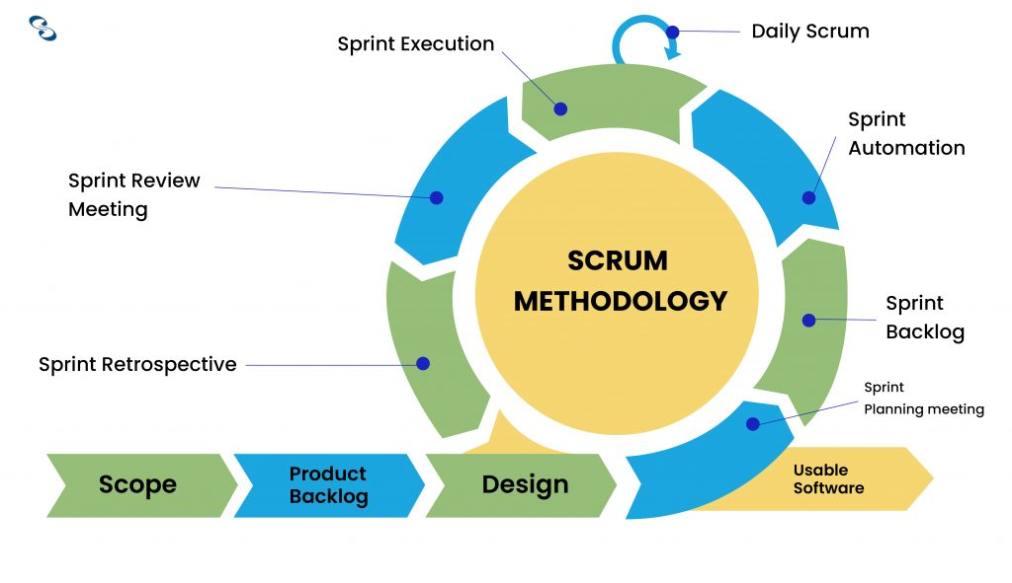

Figure 1 Scrum Methodology Model [27]

**Agile Scrum Team**

Table 2 Agile Scrum Team

|  |  |
| --- | --- |
| Role | Name |
| Team Leader/Scrum Master | Andre O. Viernes |
| Product Owner | Dan Michael C. Alfaras |
| Scrum Team | Alyssa L. Garcia  Kevin Josef Banglagan |
| Stakeholder | Francesca Erin R. Camino |

**Scrum Methodology Description**

Table 3 Scrum Methodology Description

|  |  |
| --- | --- |
| Steps | Descriptions |
| Scope | The team has planned to have the following features for the web-app: a reservation system for transactions, an online payment system, statistics, a login system, customer profiles, live and bot chat, a section for reviews and feedback, mobile optimization, a support tab, a site locator, a gallery of services, social media buttons, a 360-degree virtual tour, news and promotions, and a list of services. |
| Product Backlog | The team has listed everything the product needs to satisfy the client and customers to have deliverables discussed in Sprint Meetings. |
| Design | The team will be using the knowledge learned from System Analysis and Design (MSYADD1) to design the UI (User Interface) and UX design of the system. |
| Sprint Planning Meeting | The team will have a meeting, which is held at the start of each sprint, to decide how the project will be approached based on the phases and deadlines in the Product Backlog. |
| Sprint Backlog | The team when in the sprint backlog will be working on a subset of the product, and the team will review the list of work items that are to be completed in the specific sprint. |
| Sprint Automation | The team in the sprint automation will start testing activities at least one sprint behind the development phase, and the features/functionalities of the web-app will be tested once it is stable. |
| Daily Scrum | The team will have a daily standup to show the plans and the things that need to be carried out, as well as to see hindrances towards the completion of the work, as well as progress updates on the current work of the team. |
| Sprint Execution | The team will have and manage a task plan, perform, and finish the tasks, attend daily stand-ups, as well as have a continuous communication with the scrum team. |
| Sprint Review Meeting | The team members are set to have daily quick meetings to review informal demos and present the work they have done for the iteration. |
| Sprint Retrospective | The team will examine what went well during the last sprint cycle and what may be improved for the next sprint. |
| Usable Software | The team is set to release the usable software - which is the proposed system, for use. |

## Requirements Analysis

### Product Backlog / User Stories

Table 4 Product Backlog / User Stories

|  |  |  |  |  |  |
| --- | --- | --- | --- | --- | --- |
| **ID** | Priority | Title | User Stories | Acceptance Criteria | Estimate |
| **1** | Must | Account Creation | As a customer I want to be able to make an account for the web-app so that I can access the features of the web-app that requires an account. | Given the customer is on the login page when he/she clicks the <Sign Up> then he/she can create an account. | 3 |
| **2** | Must | Customer Login | As a customer I want to be able to login to the web-app so that I can make an appointment and write a review. | Given the customer is on the login page when he/she fills up the username and password correctly and clicks the <Login>  then he/she will now be logged into the web-app. | 1 |
| **3** | Must | Service Reservation | As a customer I want to be able to make an appointment so that I can be free from having to wait in line to start a transaction. | Given the customer is in the reservation form and has logged in to his/her account when he/she answers the reservation form then he/she can continue to pay the fee for reservation. | 3 |
| **4** | Should | Inquiries | As a customer I want to be able to get an immediate response with my general inquiries so that I can receive the requested information at once. | Given the customer navigates to the bottom right of the web-app when he/she clicks the <Chat Icon> then he/she can now send inquiry. | 5 |
| **5** | Must | Reviews | As a customer I want to be able to write a review about the establishment’s services so that I can leave my reviews to help them improve their services. | Given the customer is in the review page and logged into his/her account when he/she clicks the <Write Review> then he/she can write a review. | 3 |
| **6** | Must | Shop Details | As a customer I want to be able to know more about the establishment’s available services and shop details so that I can easily decide if I want to avail themselves of their services or not. | Given the customer was able to navigate the web-ap when he/she visits the web-app then he/she can view and navigate the services and shop details. | 5 |
| **7** | Must | Statistics | As an Admin/Management I want to be able to view the statistics of the web-app so that I can find out if the service center is performing well. | Given the Web-App has visitors and customers when Admin/Management clicks <dashboard> then he/she can view the statistics of the web-app. | 5 |
| **8** | Must | Manage Reservation List | As an Admin/Management I want to be able to manage the reservation list of the customers so that I can find out if the customers cancel their reservations or not. | Given the Web-App has customers and makes an appointment when Admin/Management clicks the <Reservations> then he/she can manage the reservation list. | 2 |
| **9** | Must | Manage Web-App | As an Admin/Management I want to be able to Manage my web-app so that I can Add, Read, Update, and Delete any content I want in the Web-app. | Given the Admin/Management has logged into their admin account when he/she clicks the <Mange Web-App>then he/she can Create, Read, Update, and Delete any content in the web-app. | 8 |

### Event Tables

Table 5 Event Table

|  |  |  |  |  |  |
| --- | --- | --- | --- | --- | --- |
| **Event** | **Trigger** | **Source** | **Use Case** | **Response** | **Destination** |
| **Customer creates an account** | Sign up | Customer | Account Creation | Sign Up Form    Privacy & Policy | Customer |
| **Customer logs in to web-app** | Login | Customer | Customer Login | Profile Details    Customer Transactions | Customer |
| **Customer wants to book**  **a reservation** | Book Now | Customer | Service Reservation | Reservation Form  Payment Options | Customer |
| **Customer wants to chat** | Chat Icon | Customer | Inquiries | Live Chat & Bot Chat | Customer & Management/  Administrator |
| **Customer wants to view and write reviews** | Review | Customer | Reviews | Review Section    Updated Review Section | Customer & Management /Administrator |
| **Customer wants to know more about the shop** | Menu | Customer | Shop Details | Services  Promos  Gallery  FAQs  Social Media Buttons  About Us | Customer |
| **Administrator/Management wants to manage the web-app** | Manage Web-App | Management  /Administrator | Managing Web-App | Updated Web-App Details | Management  /Administrator |
| **Administrator/Management wants to manage reservation list** | Reservations | Management  /Administrator | Manage Reservation List | Customer Reservation List Details | Management  /Administrator |
| **Administrator/Management wants to view statistics** | Dashboard | Management  /Administrator | Statistics | Statistics Report | Management  /Administrator |

### Use Case Diagrams

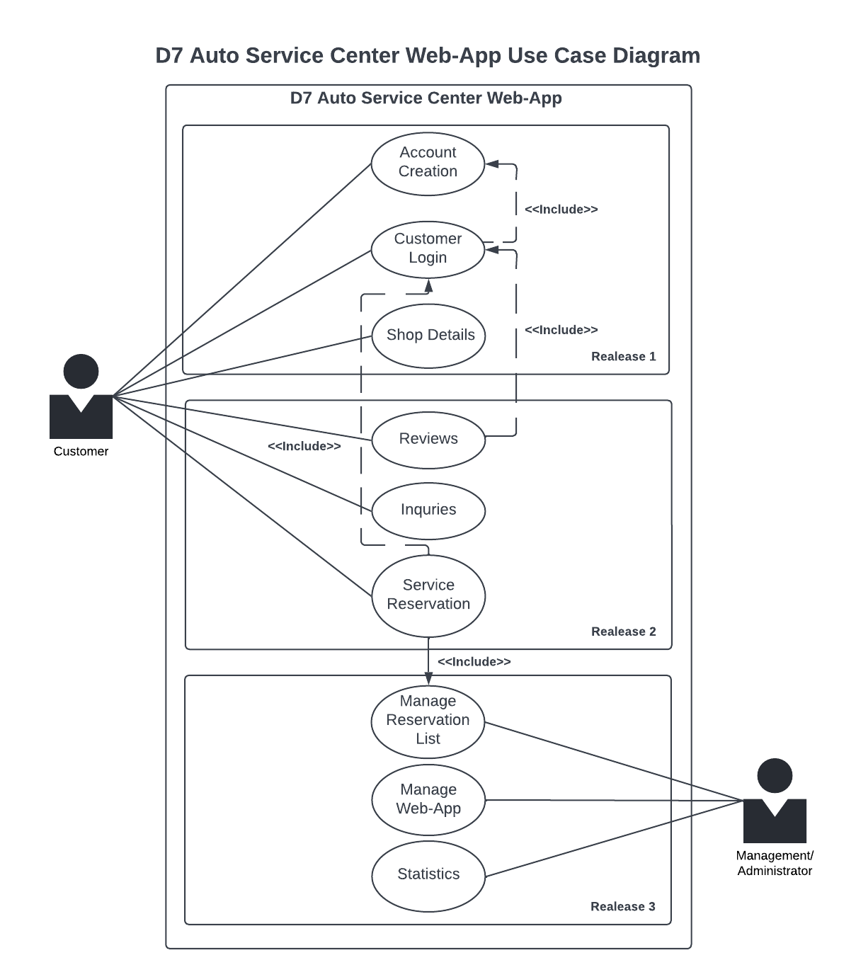

Figure 2 Use Case Diagram

### Use Case Full Description

Table 6 Use Case Full Description: Account Creation

|  |  |  |
| --- | --- | --- |
| Use Case Name: | Account Creation | |
| Scenario: | Customer creates an account | |
| Triggering Event: | Sign up | |
| Brief Description: | Customer visits web-app for the first time, then decides to create an account for buying services of the D7 Auto Service Center. | |
| Actors: | Customer | |
| Related Use Cases: | Customer Login | |
| Stakeholders: | Customers, Administrators, Management | |
| Preconditions: | 1. Customer must be on the web-app homepage 2. Customer must click the sign-up button | |
| Postconditions: | 1. Account created must reflect on system | |
| Flow of Activities: | Actor | System |
| 1. Customer Visits D7   Web-app     * 1. Customer clicks sign up button   2. Customer must set up username   3. Customer must set up password | 1. System detects a host   visit    1.2 System prepares sign up window     1. System records customer gave info |
| Exception Conditions: | 1. Customer cannot sign up if offline | |

Table 7 Use Case Full Description: Customer Login

|  |  |  |
| --- | --- | --- |
| Use Case Name: | Customer Login | |
| Scenario: | Customer logs into web-app | |
| Triggering Event: | Login | |
| Brief Description: | Customer logs into the account created in the D7 Web-app. | |
| Actors: | Customer | |
| Related Use Cases: | Account Creation | |
| Stakeholders: | Customers, Administrators, Management | |
| Preconditions: | 1. Customer must be on the web-app homepage 2. Customer must click login button 3. Customer must have an existing account | |
| Postconditions: | 1. Customer is logged in until:    1. Customer Logs out    2. Customer quits tab | |
| Flow of Activities: | Actor | System |
| 1. Customer Visits D7   Web-app     * 1. Customer clicks login button   2. Customer must input username   3. Customer must input password | 1. System detects a host   visit     * 1. System prepares login window      * 1. System confirms customer username   and password     1. System logs host to customer profile |
| Exception Conditions: | 1. Customer cannot login if offline 2. Customer cannot login if username is incorrect 3. Customer cannot login if password is incorrect 4. Customer cannot login if account does not exist | |

Table 8 Use Case Full Description: Service Reservation

|  |  |  |
| --- | --- | --- |
| Use Case Name: | Service Reservation | |
| Scenario: | Customer wants to book a reservation | |
| Triggering Event: | Book Now | |
| Brief Description: | Customer decides to book a service and the date of that servicing | |
| Actors: | Customer | |
| Related Use Cases: | Customer Login | |
| Stakeholders: | Customers, Administrators, Management | |
| Preconditions: | 1. Customer must be logged into account 2. Customer must choose a service 3. Customer must choose a date for the service | |
| Postconditions: | 1. Customer receives reservation details | |
| Flow of Activities: | Actor | System |
| 1. Customer Visits D7   Web-app     * 1. Customer logs into account      1. Customer chooses a service      * 1. Customer chooses a date | 1. System detects a host   visit     1. System logs host to customer profile      * 1. System prepares reservation promptly   2. System confirms reservation      1. System records reservation details |
| Exception Conditions: | 1. Customer cannot reserve if offline 2. Customer cannot reserve if logged out 3. Customer cannot reserve if service is unavailable 4. Customer cannot reserve if date is unavailable | |

Table 9 Use Case Full Description: Inquiries

|  |  |  |
| --- | --- | --- |
| Use Case Name: | Inquiries | |
| Scenario: | Customer wants to chat | |
| Triggering Event: | Chat Icon | |
| Brief Description: | Customer decides to request for a chat to inquire/ask information. | |
| Actors: | Customer | |
| Related Use Cases: | Shop Details | |
| Stakeholders: | Customers, Administrators, Management | |
| Preconditions: | 1. Customer must be on the Web-App home page. 2. Customer must click the chat icon | |
| Postconditions: | 1. Customer receives responses to inquiries. | |
| Flow of Activities: | Actor | System |
| 1. Customer Visits D7   Web-app     * 1. Customer clicks chat icon      1. Customer chooses a mode of chatting      * 1. Customer sends messages | 1. System detects a host   visit     1. System prepares chat prompt     2.1.1 System enables chosen mode of chatting  2.1.2 System responds to  Customer inquiries |
| Exception Conditions: | 1. Customer cannot chat if offline 2. Customer cannot chat without chosen mode of chatting | |

Table 10 Use Case Full Description: Reviews

|  |  |  |
| --- | --- | --- |
| Use Case Name: | Reviews | |
| Scenario: | Customer wants to view and write reviews | |
| Triggering Event: | Review | |
| Brief Description: | Customer decides to view reviews given by customers, and/or write a review in the reviews section. | |
| Actors: | Customer | |
| Related Use Cases: | Shop Details | |
| Stakeholders: | Customers, Administrators, Management | |
| Preconditions: | 1. Customer must be in the Web-app 2. Customer must login to write a review 3. Customer must click view reviews to view reviews | |
| Postconditions: | 1. The written review must reflect the system 2. The written review must be seen in the reviews section | |
| Flow of Activities: | Actor | System |
| 1. Customer Visits D7   Web-app     * 1. Customer clicks view reviews      1. Customer views reviews      * 1. Customer logs in   2. Customer writes a review | 1. System detects a host   visit     1. System redirects to reviews section      * 1. System displays reviews   2. System sends login prompt   3. System saves written review |
| Exception Conditions: | 1. Customer cannot view reviews if offline 2. Customer cannot write a review if not logged in | |

Table 11 Use Case Full Description: Shop Details

|  |  |  |
| --- | --- | --- |
| Use Case Name: | Shop Details | |
| Scenario: | Customer wants to know more about the services offered and shop details | |
| Triggering Event: | Menu | |
| Brief Description: | Customer decides to view services and shop details. | |
| Actors: | Customer | |
| Related Use Cases: | Inquiries, Reviews | |
| Stakeholders: | Customer, Administrators, Management | |
| Preconditions: | 1. Customer must be in the Web-app 2. Customer must choose which detail section to see | |
| Postconditions: | 1. Customer is redirected to section of Web-app requested | |
| Flow of Activities: | Actor | System |
| 1. Customer Visits D7   Web-app     1. Customer chooses section to view | 1. System detects a host   visit     1. System redirects to chosen section to view |
| Exception Conditions: | 1. Customer cannot view sections if offline | |

Table 12 Use Case Full Description: Manage Web-App

|  |  |  |
| --- | --- | --- |
| Use Case Name: | Manage Web-App | |
| Scenario: | Admin wants to manage the web-app | |
| Triggering Event: | Manage Web-App | |
| Brief Description: | Administrator decides to customize, edit, make changes in the Web-App. | |
| Actors: | Administrator | |
| Related Use Cases: | Manage Reservation List, Statistics | |
| Stakeholders: | Administrators, Management | |
| Preconditions: | 1. Administrator must log in to the Web-App 2. Administrator must click the Manage Web-App button | |
| Postconditions: | 1. Changes made must be reflected in the system | |
| Flow of Activities: | Actor | System |
| 1. Administrator logs into   Web-App     1. Administrator clicks manage web-app      * 1. Administrator makes changes   2. Administrator saves changes | 1. System detects admin   login     1. System displays admin view      * 1. System redirects admin to editing mode   2. System saves admin changes   3. System displays changes made |
| Exception Conditions: | 1. Admin cannot manage Web-App if offline 2. Admin cannot manage Web-App if not logged in | |

Table 13 Use Case Full Description: Manage reservation List

|  |  |  |  |
| --- | --- | --- | --- |
| Use Case Name: | Manage reservation List | | |
| Scenario: | Management wants to manage reservation list | | |
| Triggering Event: | Reservations | | |
| Brief Description: | Management decides to view the reservation list for the bookings. | | |
| Actors: | Management | | |
| Related Use Cases: | Manage Web-App, Manage reservation List, View Statistics | | |
| Stakeholders: | Administrators, Management | | |
| Preconditions: | 1. Management must be in the Web-App 2. Management must login to the admin’s view 3. Management must click the Manage reservation List | | |
| Postconditions: | 1. System must display reservation list of bookings. | | |
| Flow of Activities: | Actor | System | |
| 1. Management logs into Web-App      1. Management clicks Manage reservation List | | 1. System detects admin   login     1. System displays admin view     2.1 System redirects management to  reservation list |
| Exception Conditions: | 1. Management cannot manage reservation list if offline. 2. Management cannot manage reservation list if not logged in. | | |

Table 14 Use Case Full Description: Statistics

|  |  |  |
| --- | --- | --- |
| Use Case Name: | Statistics | |
| Scenario: | Management wants to view statistics report | |
| Triggering Event: | Dashboard | |
| Brief Description: | Management decides to view the statistics report | |
| Actors: | Management | |
| Related Use Cases: | Manage Web-App, Manage reservation List, Statistics | |
| Stakeholders: | Administrators, Management | |
| Preconditions: | 1. Management must be in the Web-App 2. Management must login to the admin’s view 3. Management must click Dashboard | |
| Postconditions: | 1. System must display dashboard and statistics. | |
| Flow of Activities: | Actor | System |
| 1. Management logs into Web-App      1. Management clicks Dashboard | 1. System detects admin login      1. System displays admin view     2.1 System displays dashboard and statistics |
| Exception Conditions: | 1. Management cannot view dashboard if offline. 2. Management cannot view dashboard if not logged in. | |

## Gap Analysis

Table 15 Gap Analysis

|  |  |  |  |
| --- | --- | --- | --- |
| Product Backlog ID | Current System | Proposed Changes | Impact |
| 1 |  | Customer can now create a new account for D7 Auto Service Center only | The customer will have a personal account that has all information related to D7 only |
| 2 |  | Customer can now login to their account and view their transactions with D7 | Customers are now able to see their profile details and transactions easily with the D7 Auto Service Web-App |
| 3 | Booking a reservation is manually processed by an employee through a logbook | Booking a reservation is now automatically processed through the web-app by a booking system | The customer can now easily book a reservation and view its details through the web-app's features |
| 3 | Payment is only available on-site. | Payment is now available on-site and online through bank transfer, debit/credit and EWallet. | The customer can now make payments conveniently online |
| 4 | Inquiries are sent through Facebook messenger – live chat. | Inquiries sent can be aided by either a bot chat for common inquiries or a live chat. | The customer can now get faster response with their generalized inquiries with the help of the bot chat. Live chat will still be available |
| 5 | Writing reviews on Facebook page | Writing reviews and ratings is now available in the web-app | The reviews and ratings can help the customers to have a look at the company’s service. They can also view and update the review section. |
| 6 | Viewing services and shop details on the Facebook page | Viewing services and shop details are now available on the Facebook page and web-app. | The customer can now properly figure out the available services from time to time. |
| 6 | Viewing auto servicing center’s location through Facebook page | Viewing auto servicing center’s location through web-app with site locator. | The customer can easily navigate and see the shop’s location. |
| 6 | Viewing the gallery inside the Facebook page. | Viewing the gallery is now organized on the web-app | The customer can now easily view the gallery in an organized matter without having to scroll down to view pushed back photos. |
| 6 |  | FAQs (Frequently Asked Questions) page is now available | The customer can now see the generalized questions and answers |
| 6 |  | Other social media platforms are connected through social media buttons in the web-app. | The customer can now easily visit the shop’s social media with just a click on the social media buttons |
| 6 |  | 360 virtual tour is now available | The customer can now have a feel and visualize the establishment. |
| 6 |  | Promos can now be seen in the web app | The customer can now be updated with the new available promos that the shop currently has |
| 7 | Admin/Management can only see the FB page rating, interactions, and visits | The Web-App can generate statistical reports such as the total income, least and most acquired services, and reviews. | The Admin/Management now has reports about their services and performances as well and not just about the business’ interactions online. Also, they can be able to manage the Web-app. |
| 8 | Admin/Management transfers reservation data online to the physical logbook. | The Web-app now inputs the reservation system in a database | The Admin/Management is now a lesser risk for physical access by non-employees and be able to see the customer reservation list details. |
| 9 | Admin/Management can only change their basic profile info from their Facebook page | Admin/Management can customize their web-app details and design it according to their liking | The Admin/Management now has more control over customization of their establishments’ online presence and be able to see the statistics report |

## System Analysis and Design

### Context Flow Diagram

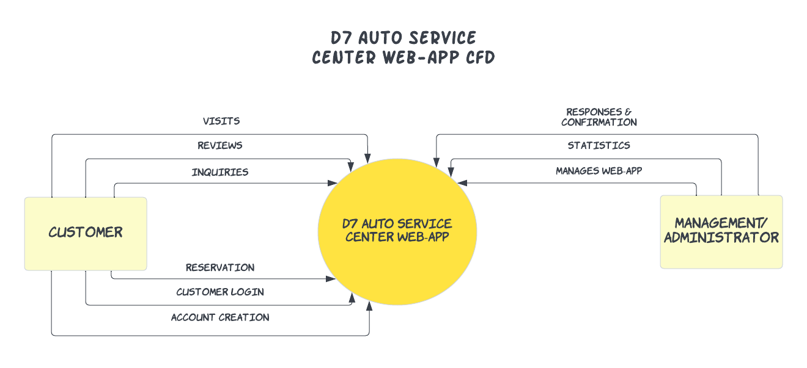

Figure 3 Context Flow Diagram

### Data Flow Diagrams

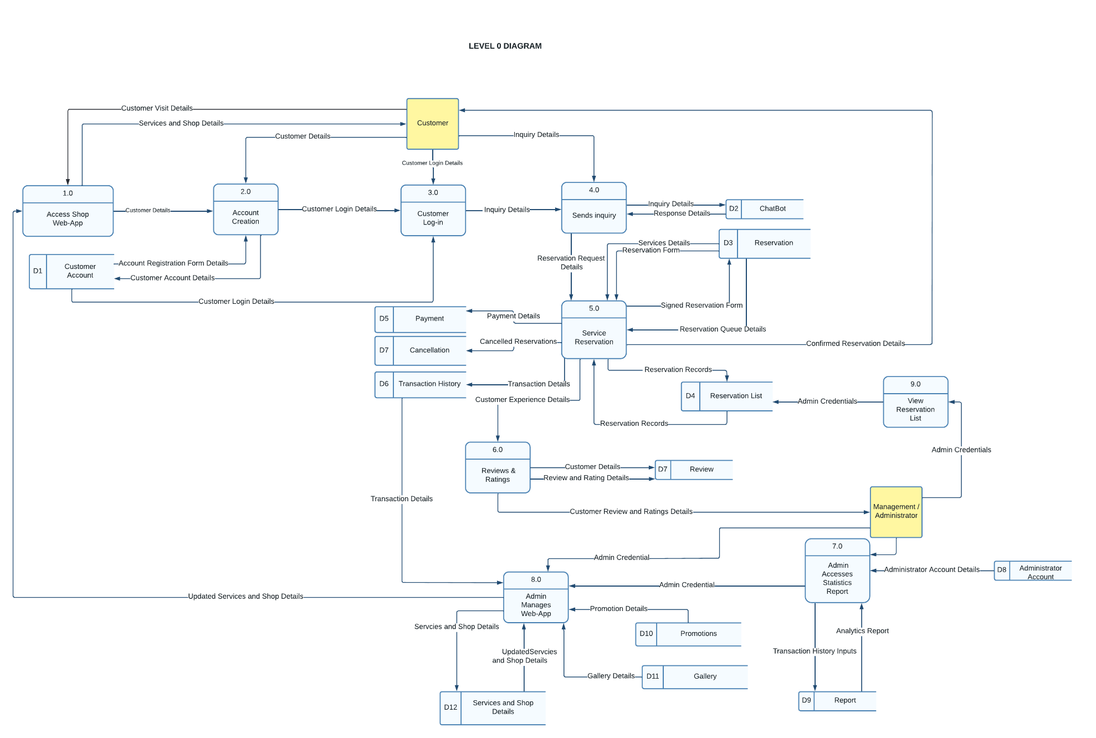

Figure 4 Data Flow Diagram: Level 0

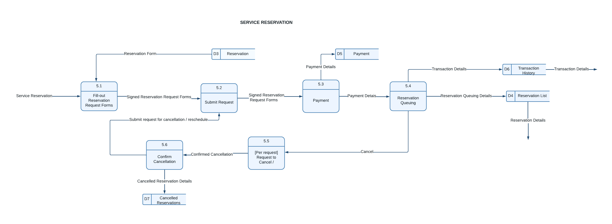

Figure 5 Data Flow Diagram: Service Reservation

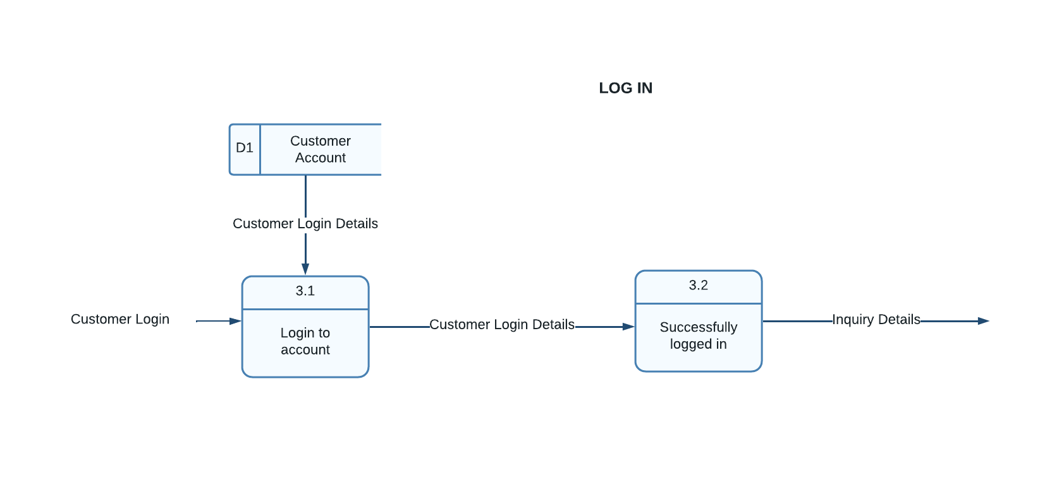

Figure 6 Data Flow Diagram: Login

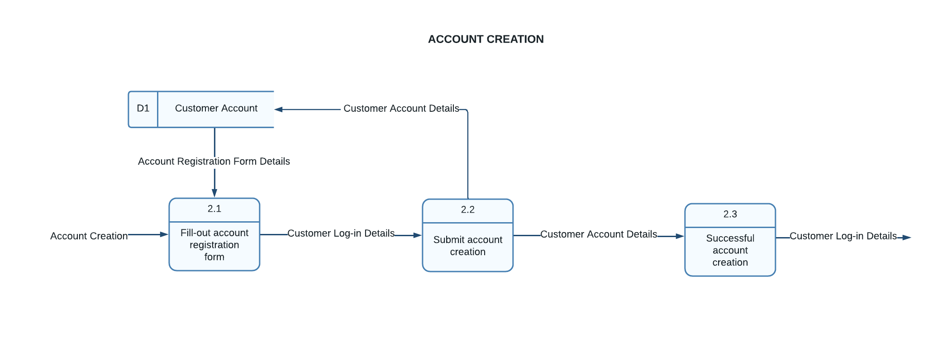

Figure 7 Data Flow Diagram: Account Creation

### Entity-Relationship Diagrams

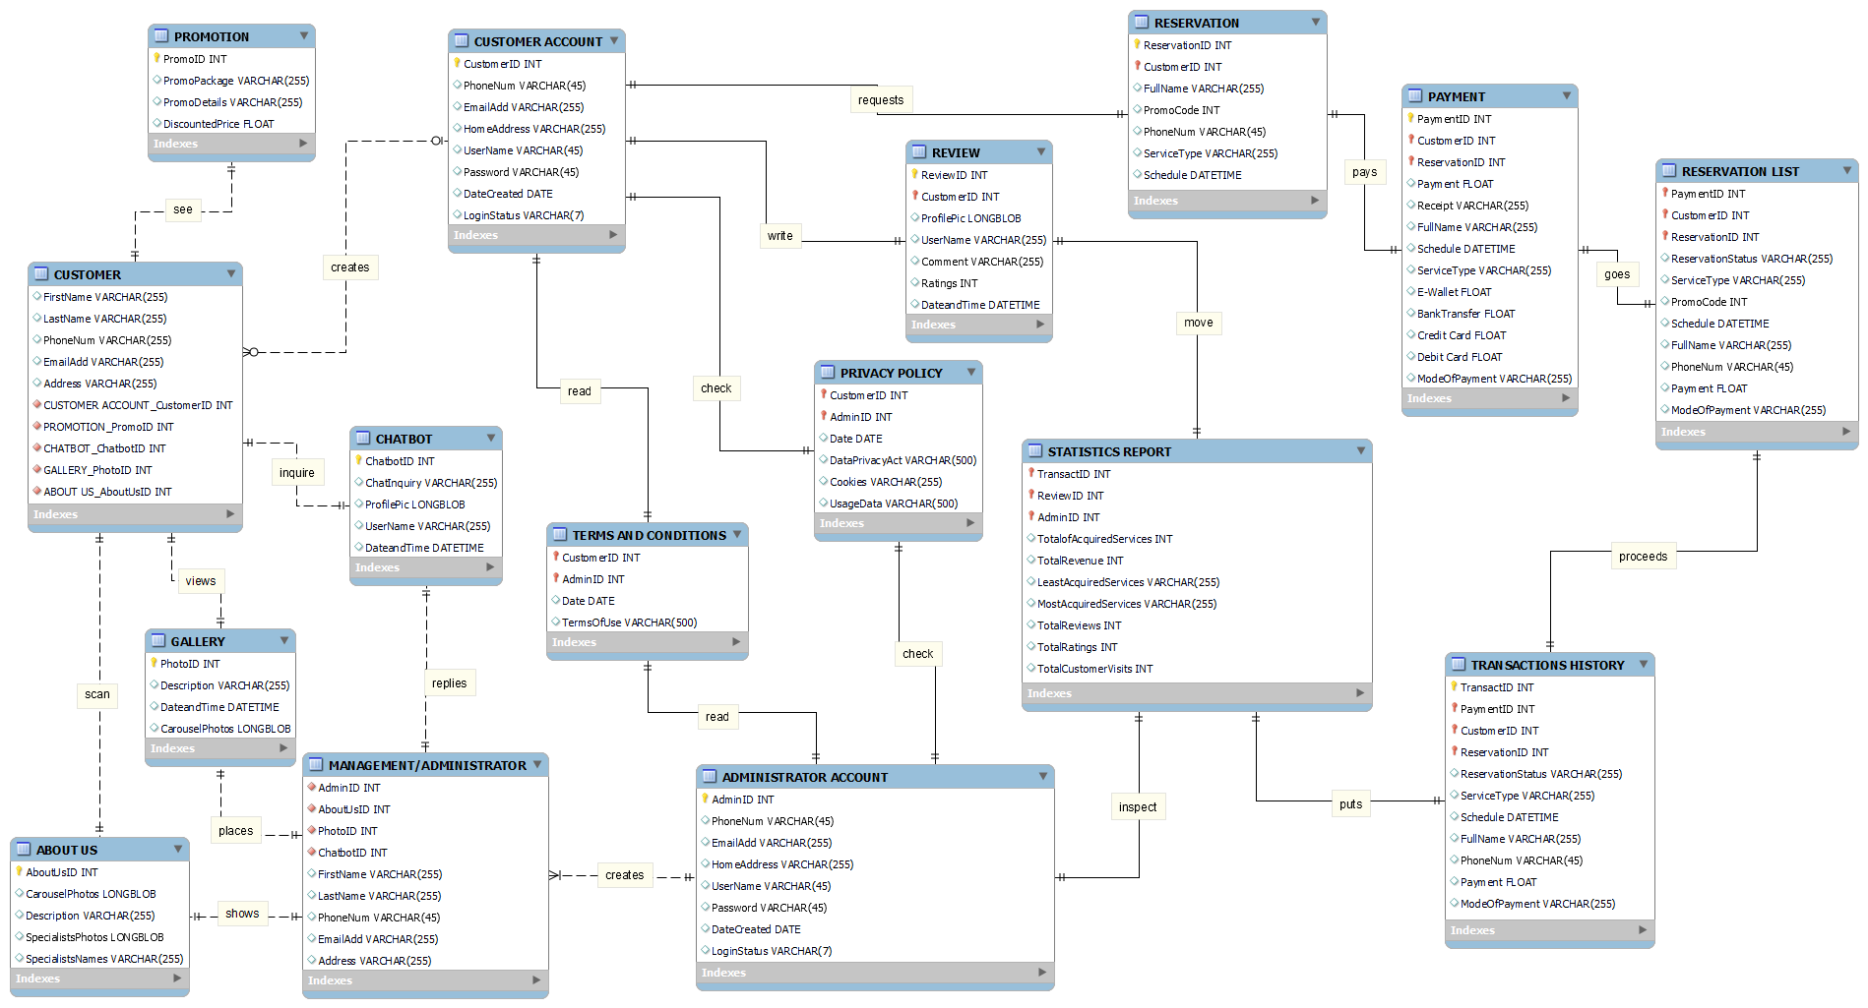

Figure 8 Entity-Relationship Diagram

### Activity Diagram

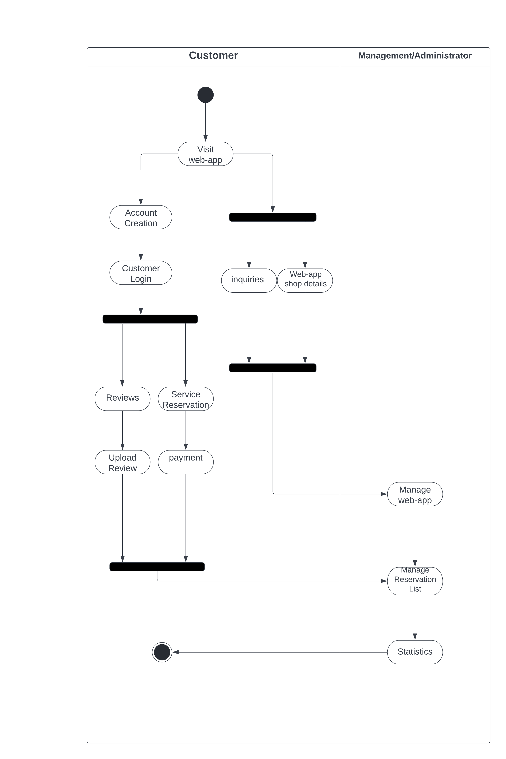

Figure 9 Activity Diagram

### Object Diagrams

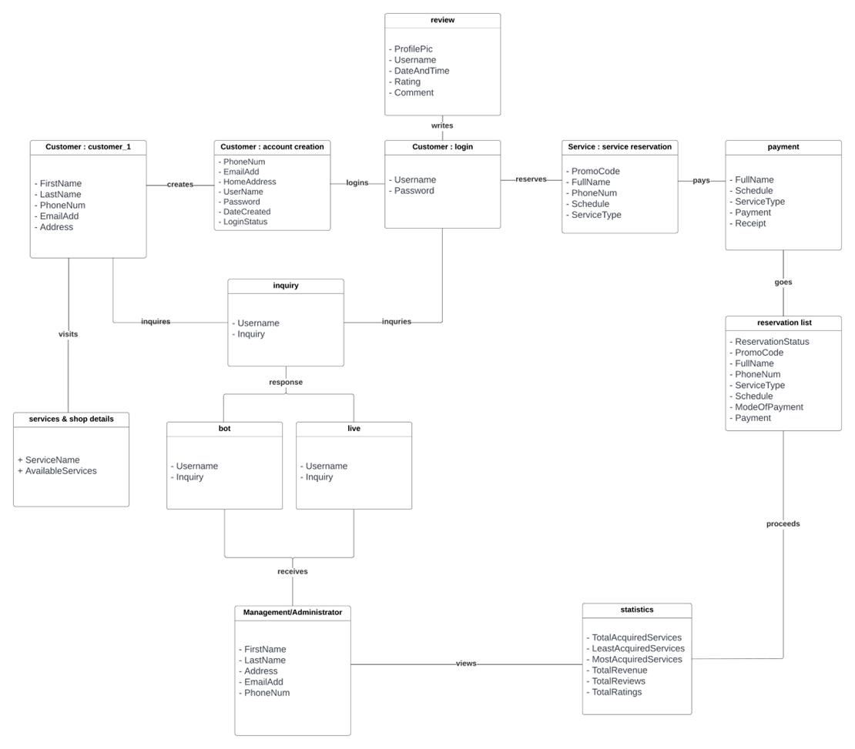

Figure 10 Object Diagram

### Class Diagrams

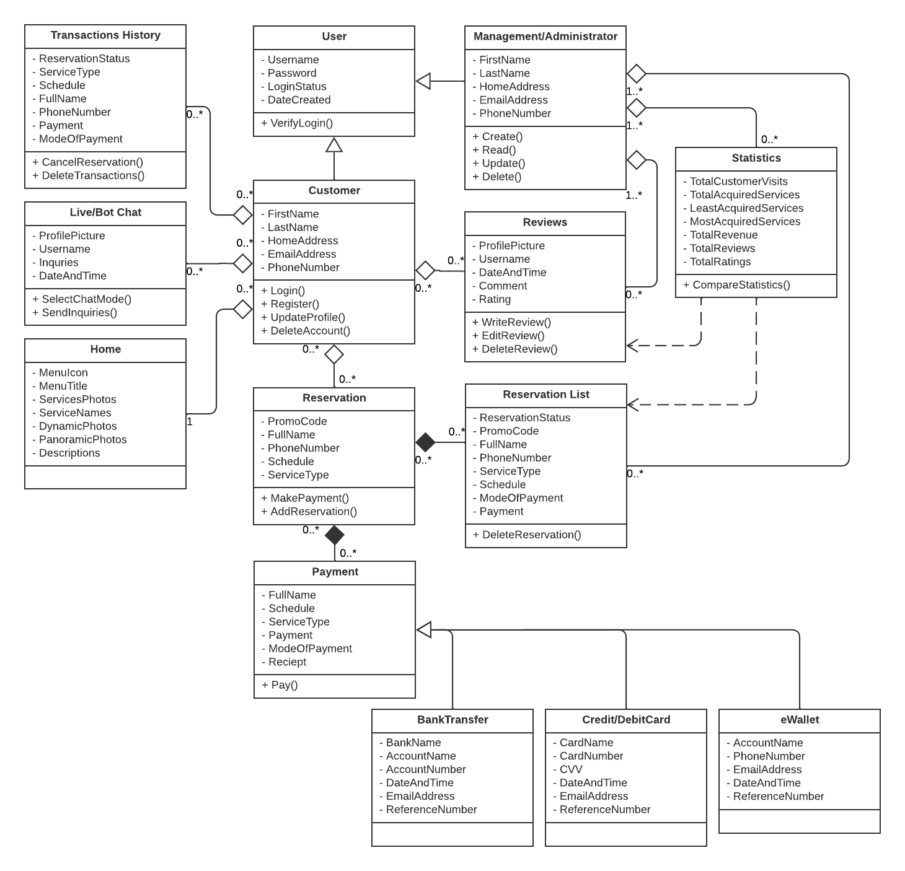

Figure 11 Class Diagram

### Sequence Diagrams

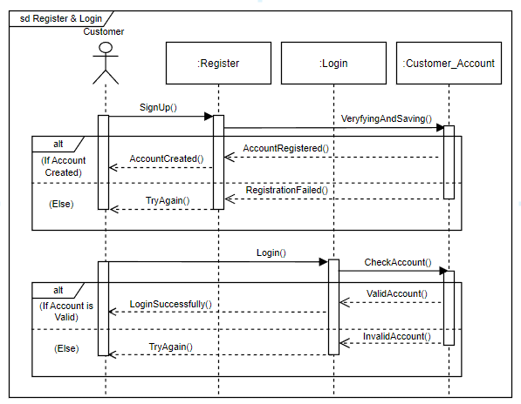

Figure 12 Sequence Diagram: Register and Login

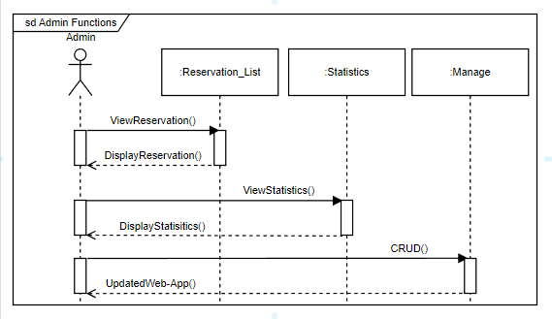

Figure 13 Sequence Diagram: Admin Functions

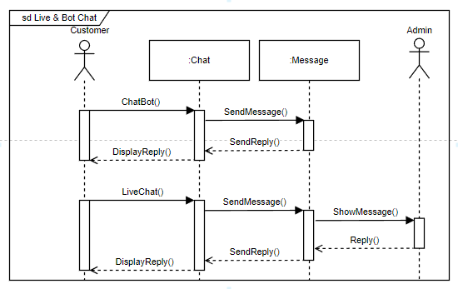

Figure 14 Sequence Diagram: Live and Bot Chat

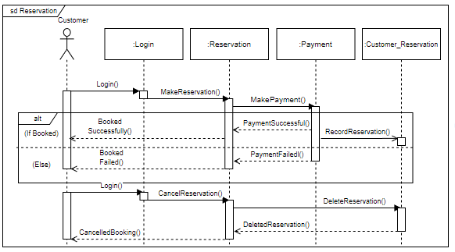

Figure 15 Sequence Diagram: Reservation

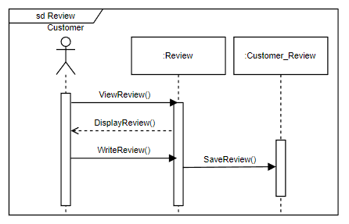

Figure 16 Sequence Diagram: Review

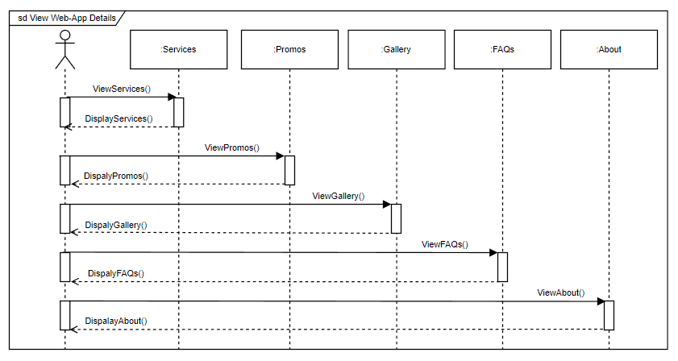

Figure 17 Sequence Diagram: View Web-App Details

### Package Diagram

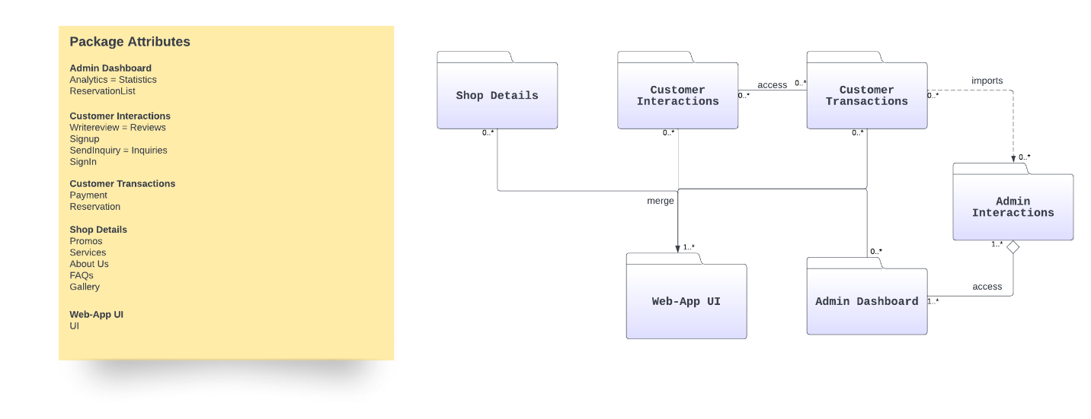

Figure 18 Package Diagram

### Component Diagram

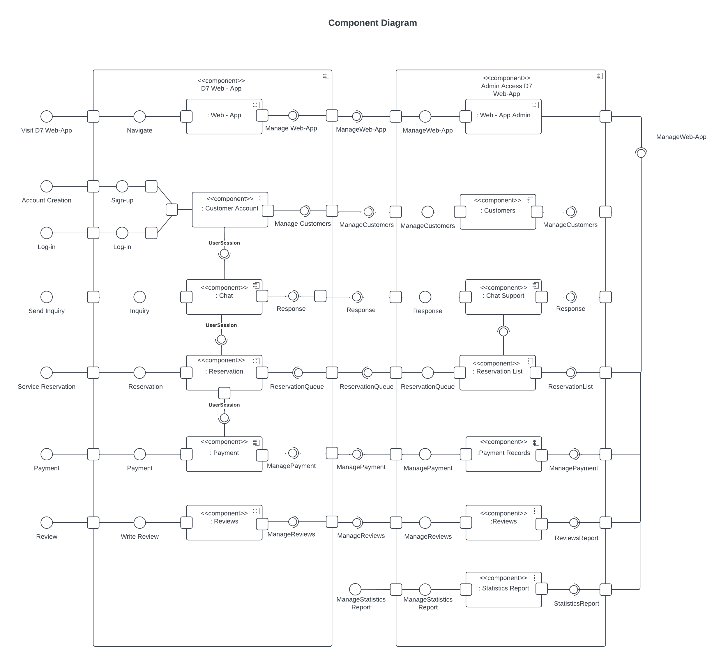

Figure 19 Component Diagram

### Deployment Diagram

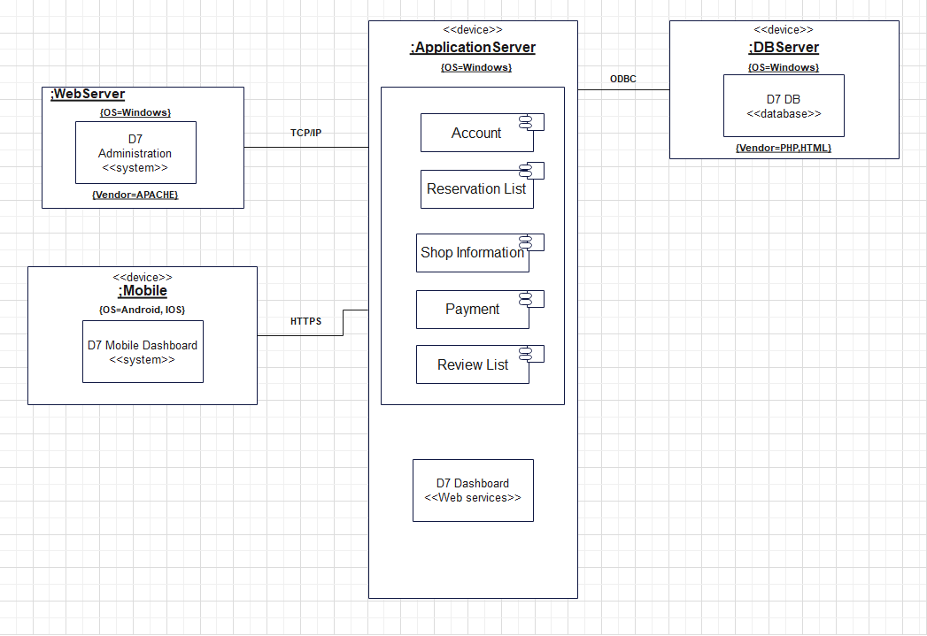

Figure 20 Deployment Diagram

### 4.3.11 State Machine Diagram

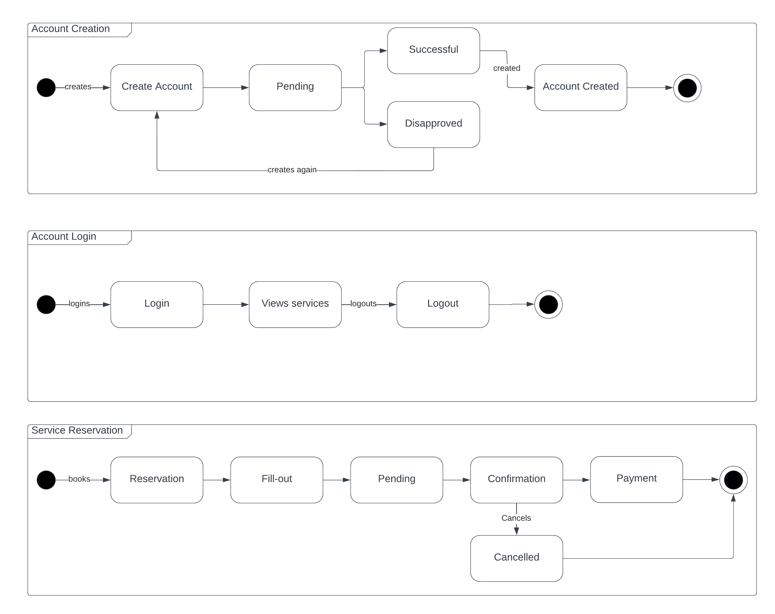

Figure 21 State Machine Diagram: Account Creation, Account Login and Service Reservation

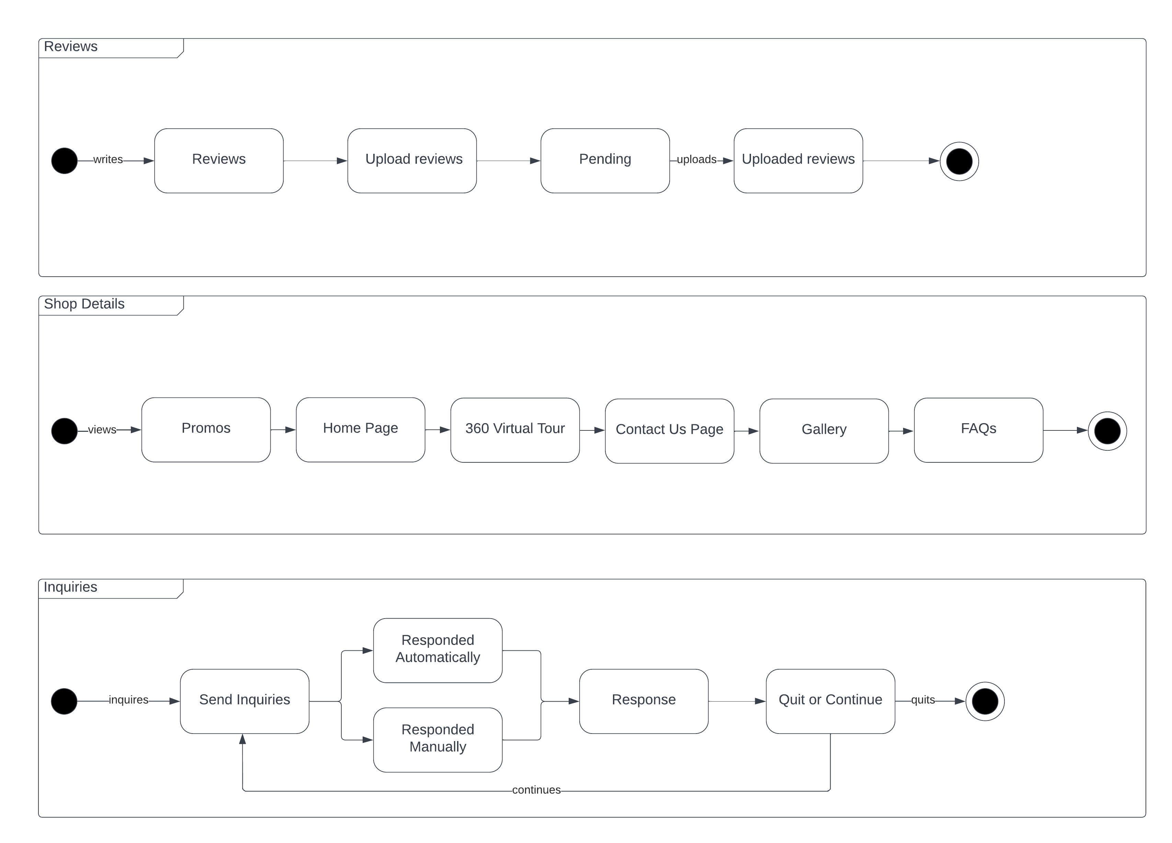

Figure 22 State Machine Diagram: Reviews, Shop Details, Inquiries

# Results and Discussion

This section will discuss the release plan of the team for the web-app as well as the prototype that will be used as reference to develop the web-app. This section will also supply use classes and characteristics to show the roles of the users inside the system.

## 5.1 Release Plan

The following table is the proposed release plan of the team. It is to prioritize the customer side of the system to enable smooth flow of interactions and visits of the customer with little to no errors. After polishing the client of the system, the team will continue to develop the admin side of the system. In line with this the team has not yet started the development of the web-app.

Table 16 Release Plan

|  |  |  |  |
| --- | --- | --- | --- |
|  | Release Plan 1 | Release Plan 2 | Release Plan 3 |
| Customer | Account Creation    Customer Login    Shop Details | Reviews    Service Reservation    Inquiries |  |
| Management  /Administrator |  |  | Manage Web-App    Manage Reservation List    Statistics |

## 5.2 Prototype

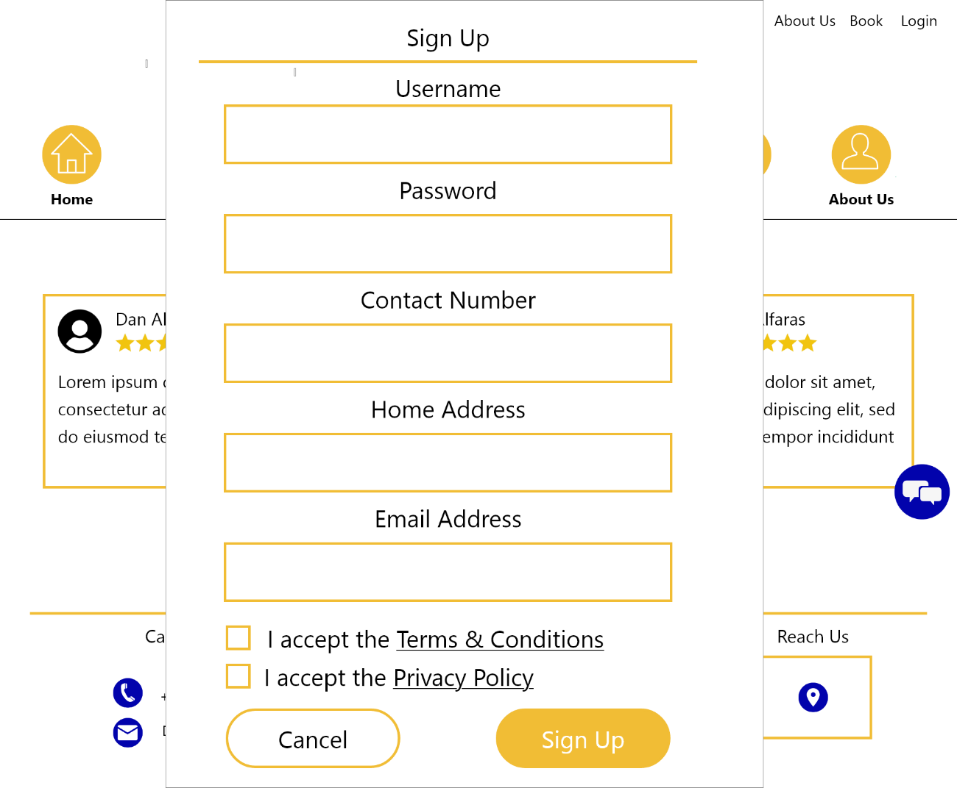

Figure 23 Sign Up

This prompt allows the customers to sign up

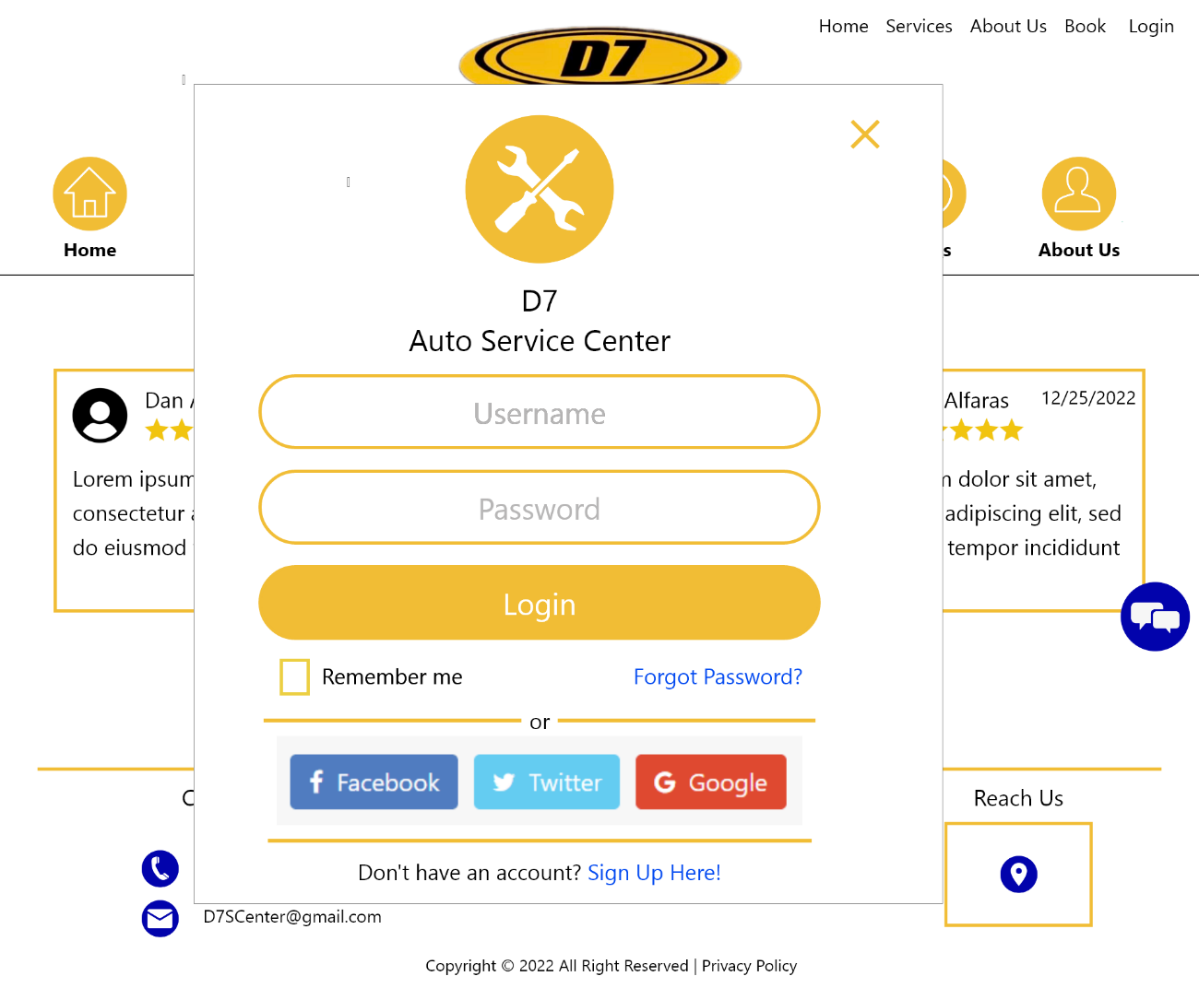

Figure 24 Login

This prompt allows the customer to login to the web-app to access the features that require an account.

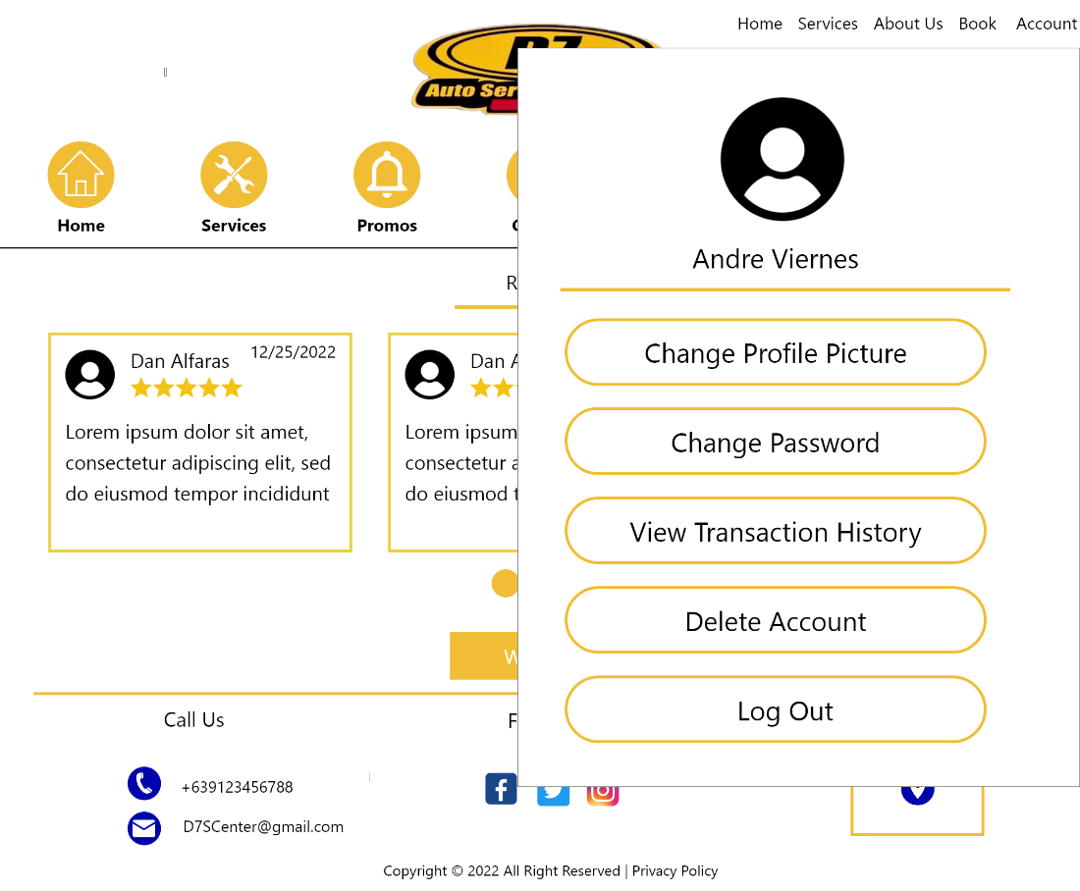

Figure 25 Customer Profile

This prompt allows the customers to Delete Account, View Transaction History, Change Password and Update their Customer Profile.

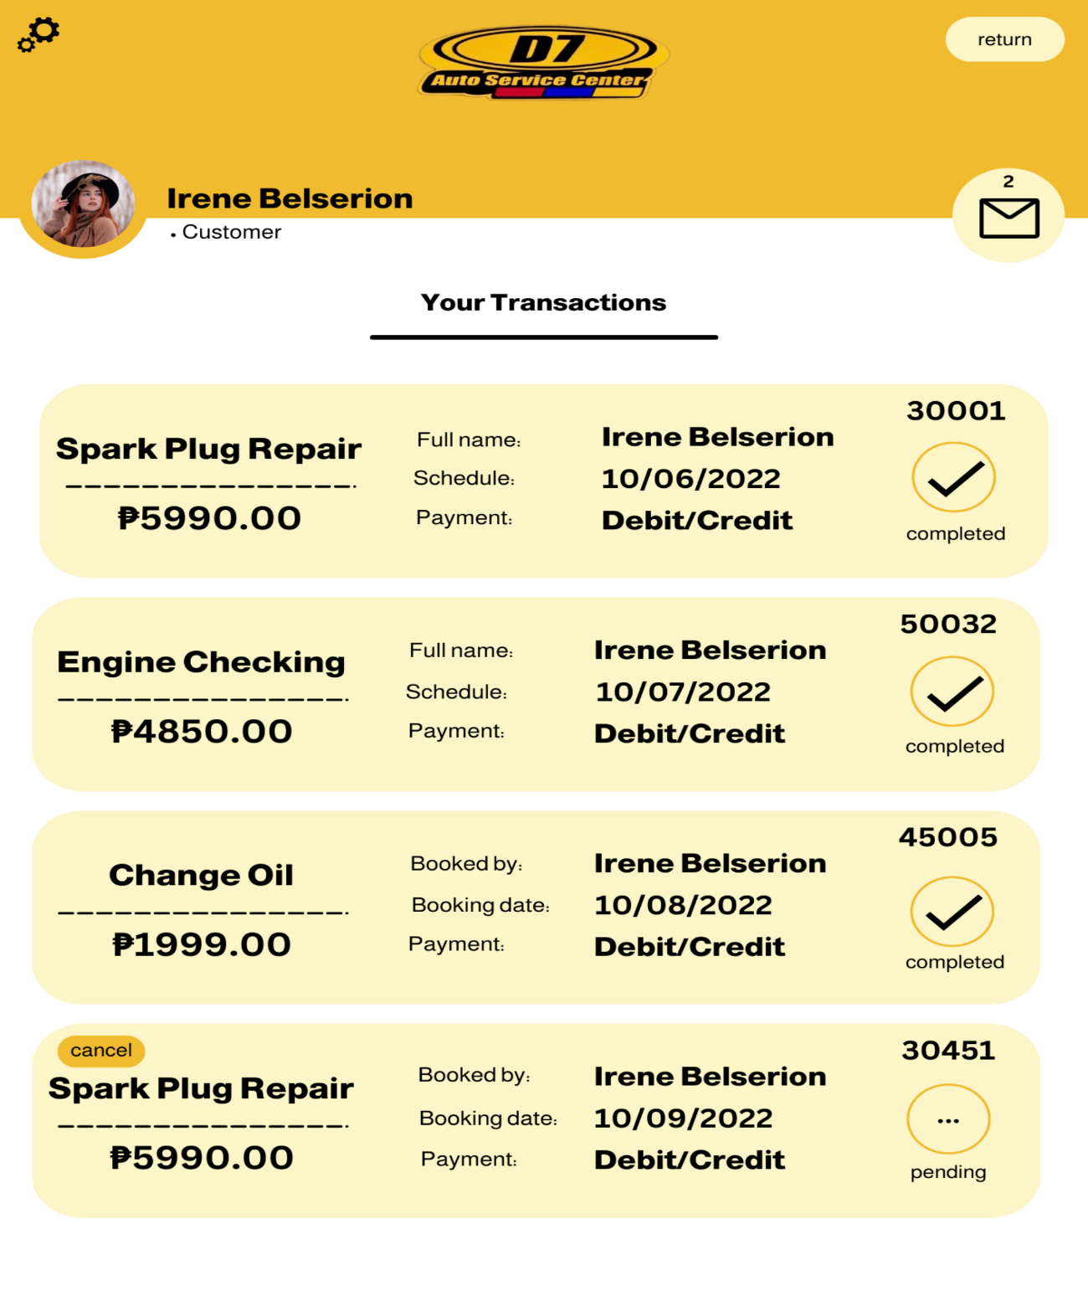

Figure 26 Transaction History

This section allows the customer to view their transaction and cancel their reservation.

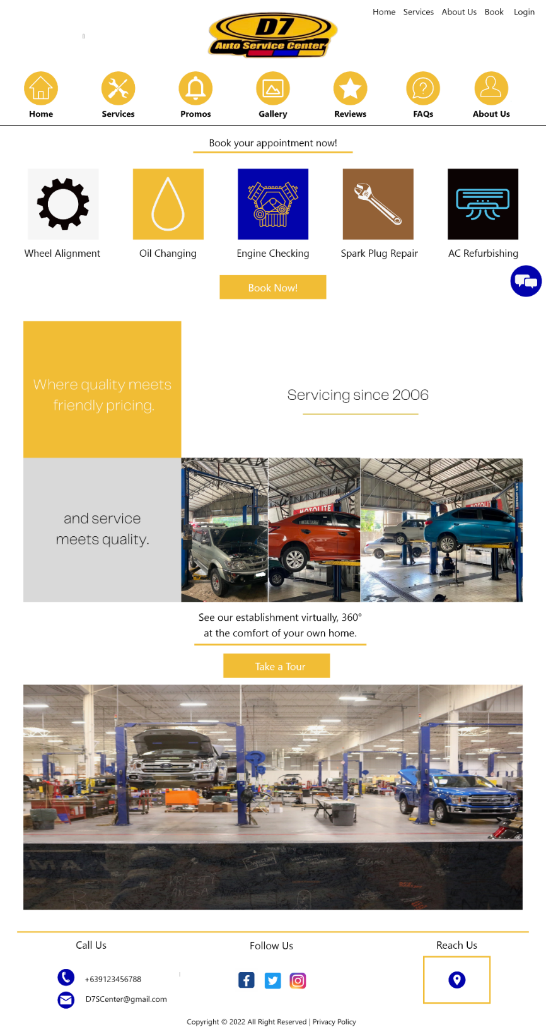

Figure 27 Home Page

This section displays some of the services available and the 360 virtual tours of the D7 Auto Service Center.

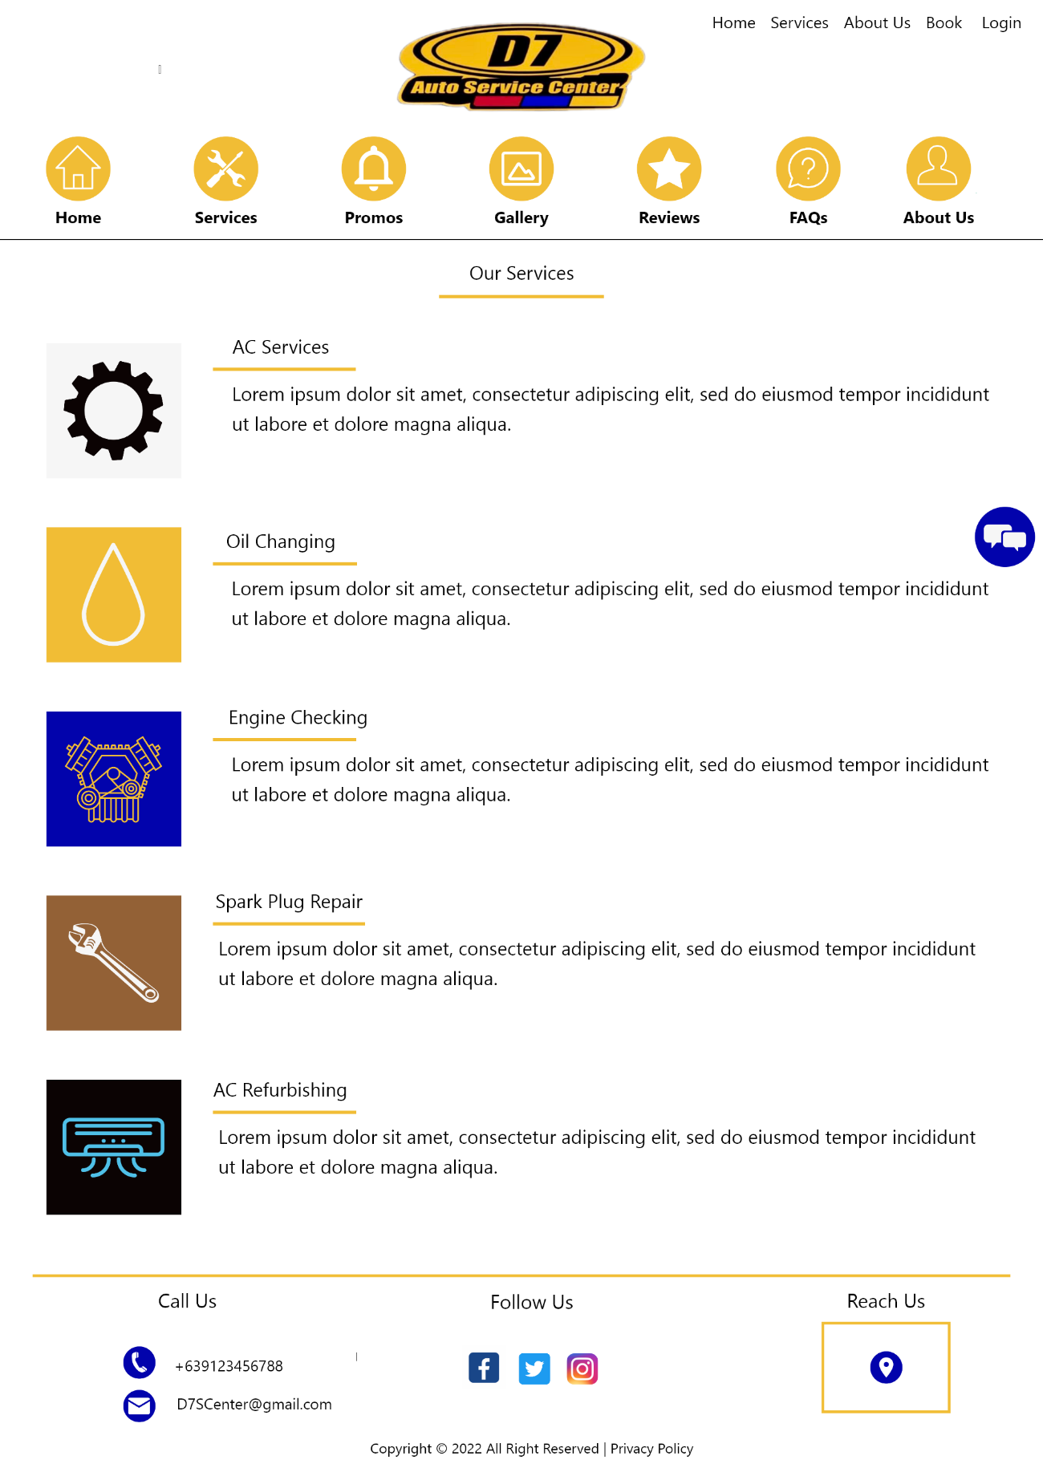

Figure 28 Services

This section where the customer can view all the available services in detail.

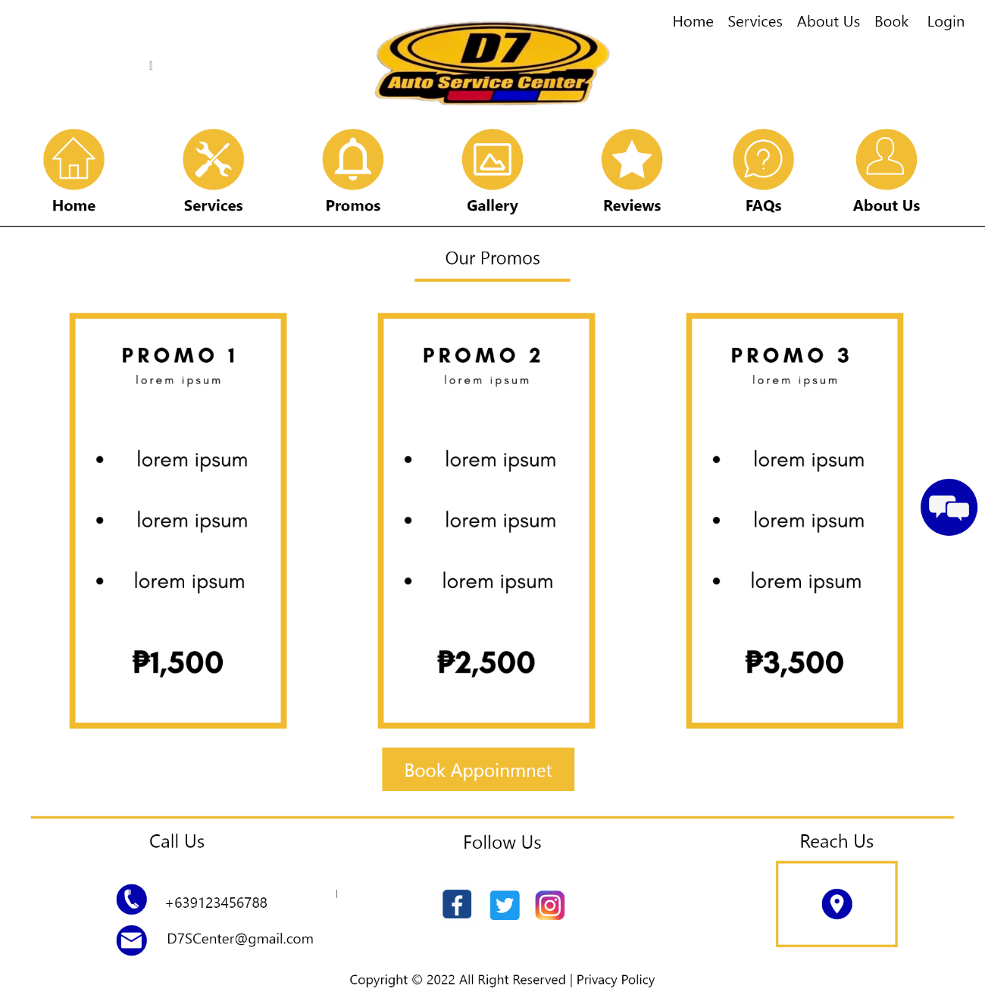

Figure 29 Promos

This section will display the promotions offered by D7, for customers to see the different options available.

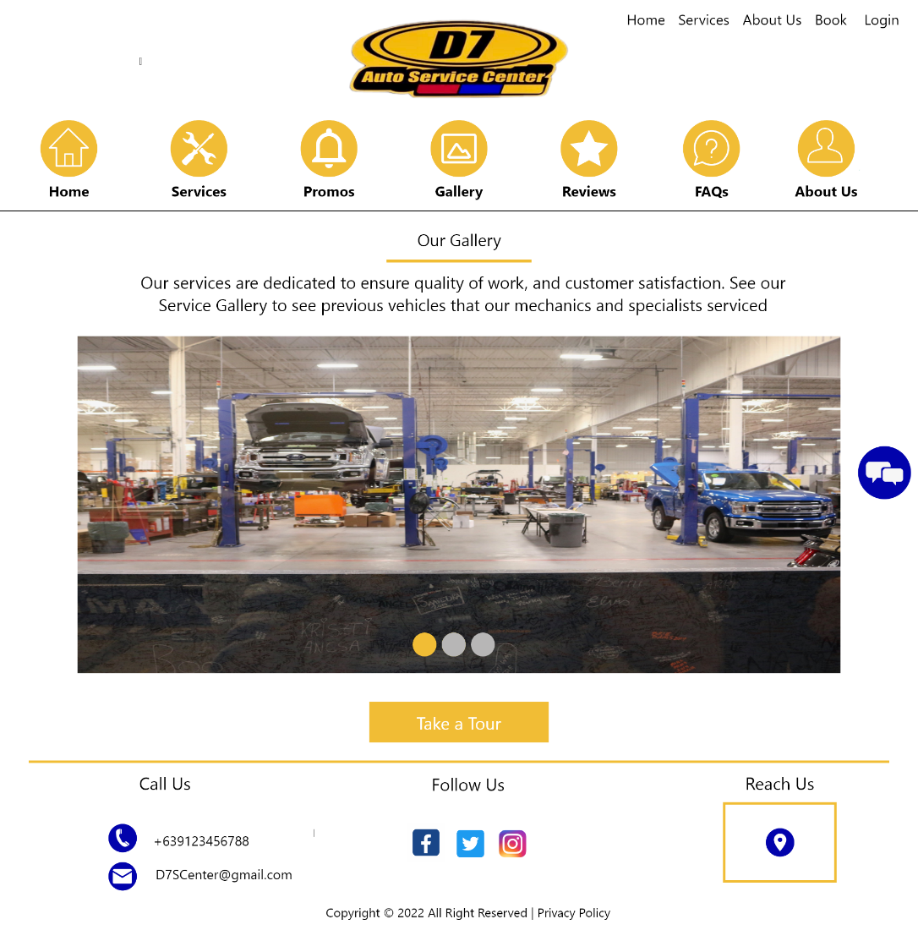

Figure 30 Gallery

This section allows the administrator/management upload photos of the serviced vehicles, for customers to see that there are a lot of customers that come by to avail themselves of their services.

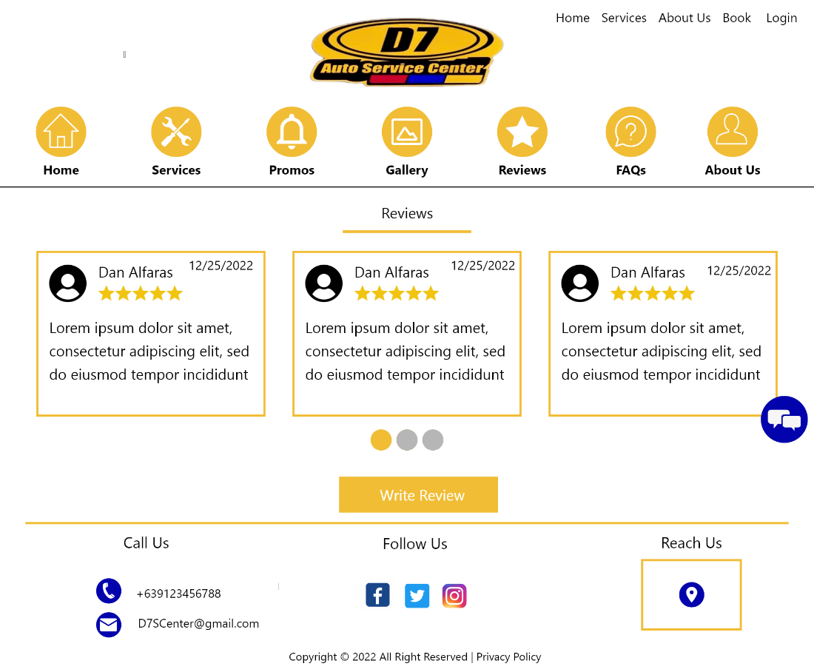

Figure 31 Reviews

This section displays the fair share of experiences from the past customers of D7 Auto Service Center.

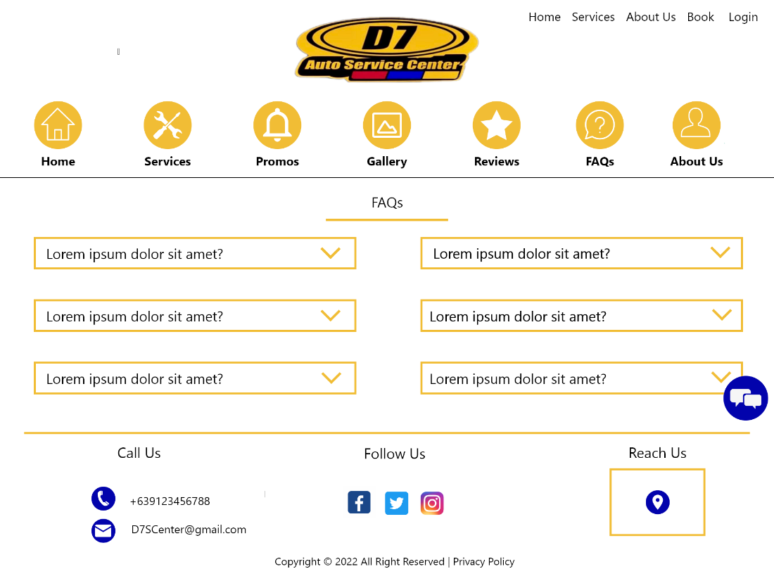

Figure 32 FAQs

This section will help the customer to have an immediate response to questions that clients may have.

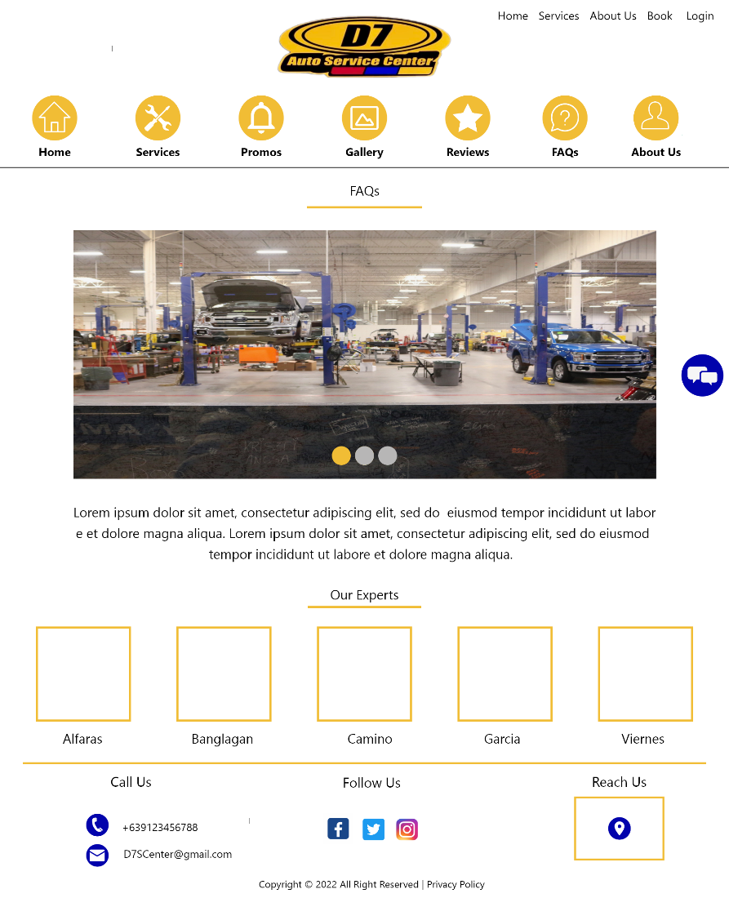

Figure 33 About Us

This section allows the customers to view the outstanding history of D7, together with their specialists.

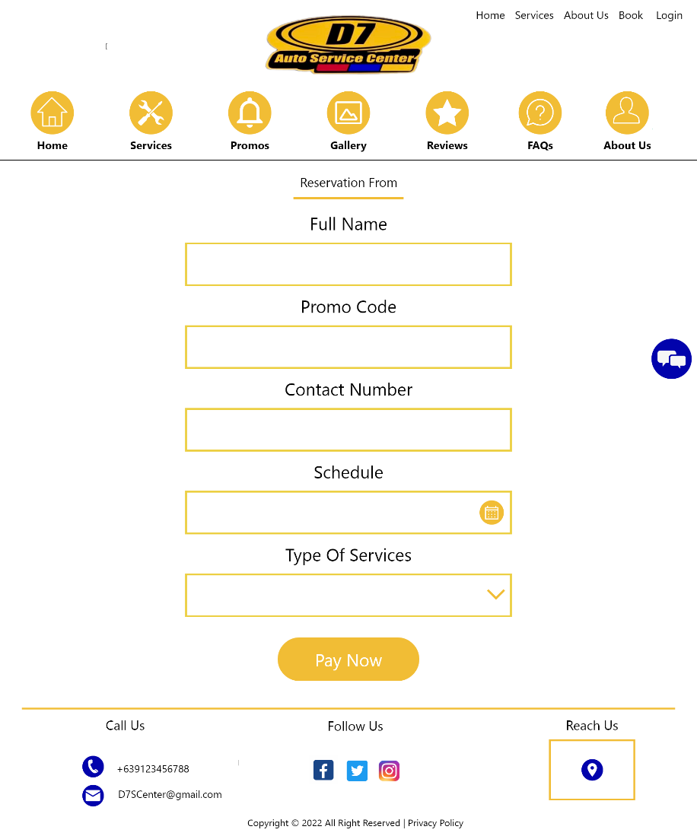

Figure 34 Reservation Form

This section allows the customers to make a reservation and to pay for the base price of the acquired services.

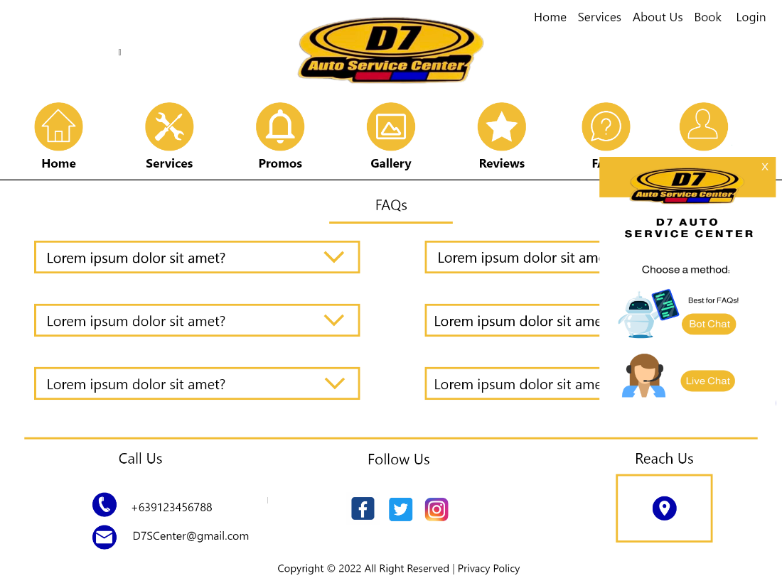

Figure 35 Chat Box

This section/prompt allows the customers to select chat mode for sending inquiries.

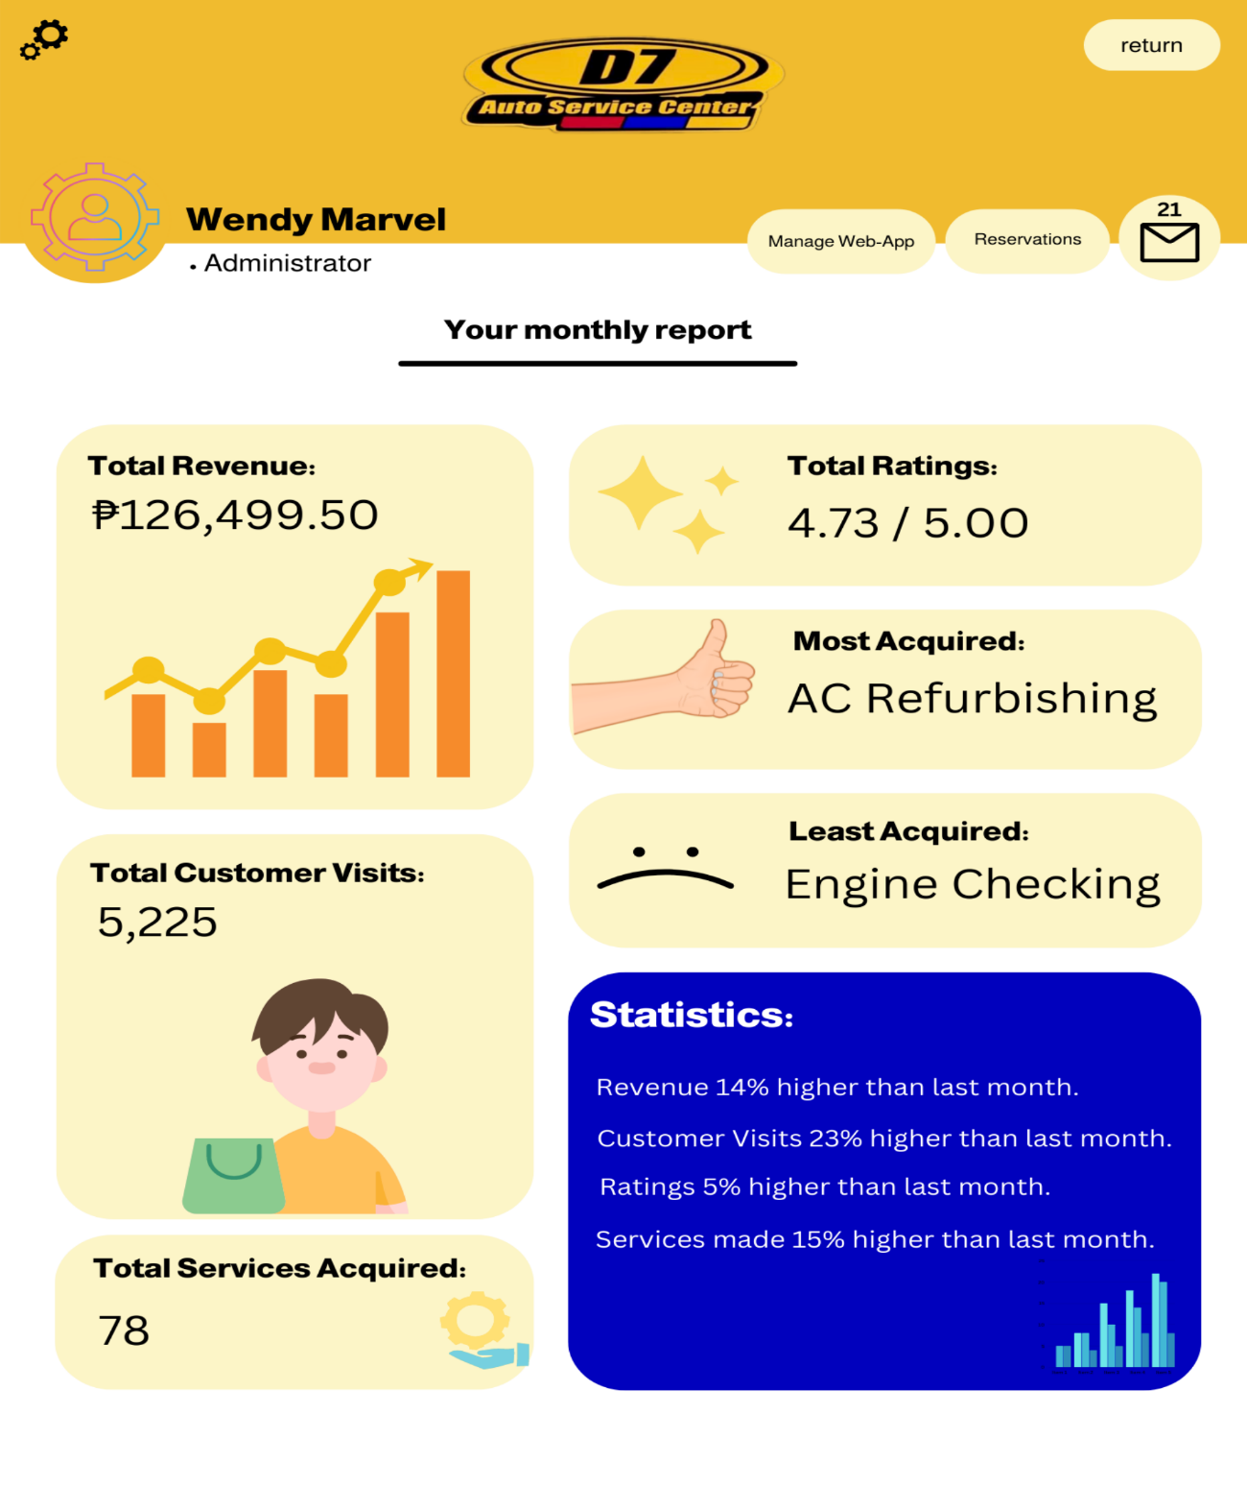

Figure 36 Dashboard

This section allows the management/administrator to view the statistics, reservation list, and manage the web-app.

## 5.3 Use Classes and Characteristics

Table 17 Use Classes and Characteristics

|  |  |  |
| --- | --- | --- |
| Roles | | Description |
| Management/Administrator | | A type of user that can Create, Read, Update, and Delete content in the entire web-app and communicate with customers via live chat. |
| Customer | A type of user that can view the content of the web-app, chat with the management/administrator, create an account, login to the website to be able to make a reservation, write a review, and pay for their services gotten online. | |

# Conclusion

With the 13 weeks the team had in the MSYADD1 term, the team’s progress includes making the following diagrams listed in the Systems and Analysis Design that has been checked by the team’s project adviser, project consultant, and with the approval of the team’s instructor. The team was able to do the following in response to the aims:

* Create all UML diagrams needed for both the existing system and for the proposed system.
* Create a Context Flow Diagram to define and clarify the boundaries of the system. To show the way the information flows between the system and external entities.
* Create a Data Flow Diagram to visually stand for the business’ systems and processes, to be able to have a better plan out the launch of a new system for implementation.
* Create an Entity Relationship Diagram to give a look at how entities relate to each other.
* Create an Activity Diagram to illustrate business processes and use cases, as well as to record how the system procedures have been put into place.
* Create an Object Diagram to show the instances in a system and their connections with one another. The team can investigate the system's behavior at a certain point in time by constructing an object diagram.
* Create a Class Diagram to depict the relationships between the system's components' relationships, model the components' interactions, and define the functions and services of the components.
* Create a Class Package Diagram to reduce the complexity in view of the Class Diagram.
* Finalize the Entity Relationship Diagram which matches the UI of the web-app and its database.
* Create the Deployment, State Machine, Component, Sequence Diagram as requirement for the finals of MSYADD1.
* Revised the paper accordingly with the corrections and suggestions of the consultants, advisers, and the panelist.

In the upcoming term, the team will continue to deliver the required deliverables, as well as continuation for the MSCPROJ. The team will also continue to have scheduled meetings with their project advisers, and project consultants next term to supply updates and comprehensive checking.

# References

|  |  |
| --- | --- |
| [1] | S. Thimothy, "5 Reasons why Facebook is bad for small businesses," *Click X.* |
| [2] | Awesome, "Website vs Social Media: What's the difference and do I need both?," *Awesome,* 2020. |
| [3] | J. Clabaugh, "Your business’ social media isn’t enough. You really still need a website," *Wtop News,* 2019. |
| [4] | Revfine, "Why is an Integrated Online Booking System Important?," *Revfine.* |
| [5] | S. Jordan, "76% of Consumers Look at Online Presence Before Physically Visiting a Business," *Cision,* 2021. |
| [6] | December Communications Inc., "Innovate," *December Communications Inc.,* 2022. |
| [7] | Harford, "Do You Really Need a Website?," *The Hartford,* 2022. |
| [8] | A. Reshard, "Developing a website for online consumers to find foreign businesses in Finland," 2021. [Online]. Available: https://www.theseus.fi/bitstream/handle/10024/511595/Reshard_Alexandria.pdf?sequence=2&isAllowed=y. [Accessed 27 April 2022]. |
| [9] | Yellow Bird Auto Center, "Yellow Bird Auto Center," Yellow Bird Auto Center, [Online]. Available: https://www.yellowbird-autocenter.com/. [Accessed 2 June 2022]. |
| [10] | Pioneer Auto Repair shop, "Pioneer Auto Repair shop," Pioneer Auto Repair shop, [Online]. Available: https://www.pioneerautobody.net/. [Accessed 2 June 2022]. |
| [11] | Galson Auto Body, "Galson Auto Body," Galson Auto Body, [Online]. Available: https://www.galsonauto.com/. [Accessed 2 June 2022]. |
| [12] | "Rapide Auto Service Experts," [Online]. Available: https://rapide.ph/. [Accessed 23 June 2022]. |
| [13] | "Centinnial Auto Services, Inc.," [Online]. Available: http://centennialauto.ph/#. [Accessed 23 June 2022]. |
| [14] | "MechaniGo.Ph," [Online]. Available: https://mechanigo.ph/about. [Accessed 23 June 2022]. |
| [15] | B. Clark, "How much does a website increase sales?," *Acquire,* 2022. |
| [16] | A. Khlystova, "5 Benefits of Live Chat for Your Business (Infographic)," *Help Crunch,* 2022. |
| [17] | C. Campbell, "New Study Highlights the Importance of Online Reviews in Local Search," *Social Media Today,* 2017. |
| [18] | Visual Studio Code, "Why did we build Visual Studio Code?," Visual Studio Code, 1 September 2022. [Online]. Available: https://code.visualstudio.com/docs/editor/whyvscode. [Accessed September 2022]. |
| [19] | PHP, "What is PHP?," PHP, [Online]. Available: https://www.php.net/manual/en/intro-whatis.php. [Accessed September 2022]. |
| [20] | Java T point, "Xampp tutorial," Java T point, [Online]. Available: https://www.javatpoint.com/xampp. [Accessed September 2022]. |
| [21] | MySQL, "What is MySQL?," MySQL, [Online]. Available: https://dev.mysql.com/doc/refman/8.0/en/what-is-mysql.html. [Accessed September 2022]. |
| [22] | wpbeginner, "What is: Apache," wpbeginner, [Online]. Available: https://www.wpbeginner.com/glossary/apache/. [Accessed September 2022]. |
| [23] | w3schools, "HTML Introduction," w3schools, [Online]. Available: https://www.w3schools.com/html/html_intro.asp. [Accessed September 2022]. |
| [24] | w3schools, "CSS Introduction," w3schools, [Online]. Available: https://www.w3schools.com/css/css_intro.asp. [Accessed September 2022]. |
| [25] | Kinsta, "What Is GitHub? A Beginner’s Introduction to GitHub," Kinsta, 16 September 2022. [Online]. Available: https://kinsta.com/knowledgebase/what-is-github/. [Accessed September 2022]. |
| [26] | w3schools, "What is Bootstrap?," w3schools, [Online]. Available: https://www.w3schools.com/whatis/whatis_bootstrap.asp. |
| [27] | K. Casey, "Everything you need to know about Scrum Methodology," 28 December 2021. [Online]. Available: https://codersera.com/blog/what-is-scrum-methodology/. |
| [28] | A. Davies, "What is Agile Methodology?," DevTeam.Space, [Online]. Available: https://www.devteam.space/blog/what-is-an-agile-methodology/. [Accessed 25 September 2022]. |

# Appendices

## Appendix A: Project Vision

**For** D7 Auto Service Center’s Marketing Team,

**Who** aims to have a platform that will help them resolve their struggles in their current system and be able to advertise their services, and their Service Center.

**The** D7 Auto Service Center Web-App is a web application project

**That** aims to give D7 an added platform that helps them advertise their services offered, while it also adds online presence for the company. This project also aims to have an online reservation and payment system, generated monthly reports of the number of people that got the services, number people who visited the page, which services were least, and most acquired, total income made, and overall ratings and number of reviews. The project also aims to utilize statistics using the monthly reports, to evaluate the business' performance as a basis for better decision making.

**Unlike** the competitors of D7 where most of them use Facebook as a marketing platform for their service, they struggle not only with making their establishment stand-out.

**Our Product** offersthe basic features to cater D7’s needs such as *live and bot chat features, review/feedback section, social media buttons as links, Gallery, Site Locator, About Us, Promos and Services, mobile optimization,* while it also offers innovative features such as *Online payment and reservation system, customer and admin login, 360 virtual tour of the establishment, Supports Tab, monthly reports of acquired services through a dashboard that shows: which services were least, and most acquired, total customer review ratings, total customer reviews, and total generated revenue, as well as statistics to help the business evaluate its performance for better decision-making.*

*.*

## Appendix B: Schedule

|  |  |
| --- | --- |
| Week | Learning Deliverables |
| 01 | 1. The team was assigned to transfer the MNTSDEV final set of requirements to a new project channel in MSYADD1. 2. After creating the channel, the team was assigned to dump all the files into the new project channel. 3. The team was assigned to select a project adviser and consultant/s. 4. The team was assigned to secure the signature of the project adviser and consultant/s by filling in the proper forms. |
| 02 | 1. The team was assigned to create an MVC infographic that illustrates the MVC framework and to supply an example derived from the project. 2. The team was assigned to put all the information on one ppt slide, describing how the MVC works. 3. After finishing the MVC, they were assigned to upload it to the group project channel and in the GitHub project repository, |
| 03 | 1. The team was assigned to create an event table for the existing process of D7 Auto Service Center |
| 04 | 1. The team was assigned to create an event table for the existing process of D7 Auto Service Center. 2. The team was assigned to create a Data Flow Diagram. 3. The team was assigned to create a Use Case Diagram. 4. The team was assigned to create an ERD. |
| 05 | 1. Existing Diagrams of the D7 Auto Service Center:  * Object Diagram * Activity Diagram  1. Proposed Diagram of the D7 Auto Service Center:  * Event table * Context Flow Diagram (CFD) * Use Case Diagram (UCD) * Use Case full description * Data Flow Diagram (DFD) * Entity Relationship Diagram (ERD) Level 0 & Level 1 |
| 06 | 1. The team was assigned to update and complete our midterm paper: 2. Introduction 3. Review of Related Literature and Systems 4. Technical Background 5. Methodology (from 4.1 to 4.3.6) 6. The team was assigned to update our proposal video 7. The team was assigned to update our Comment Matrix 8. The team was assigned to update our presentation deck |
| 07 | 1. The team was assigned to present the midterm project presentation. 2. The team was assigned to present the MNTSDEV panelists’ comments and updates made by the group to address the suggestions. |
| 08 | The team was assigned and carried out to study the following diagrams:   * Sequence Diagram * State Machine/ Transition Diagram * Package Diagram * Deployment Diagram * Component Diagram |
| 09 | The team was assigned to create the following diagrams:   * Sequence Diagram * State Machine/ Transition Diagram * Package Diagram * Deployment Diagram * Component Diagram * Finalized ERD * Data Dictionary |
| 10 | 1. The team was assigned to create the draft of presentation and videos  2. The team was assigned to create:   * Quality review of diagrams * Interface designs * Initial code review of prototype |
| 11 | 1. The team was assigned to create the sprint 3 output:  * Updated Wiki and GitHub * Pre-final presentation with project adviser * Project adviser endorsement for final presentation * Project adviser project group evaluation |
| 12 | 1. The team was assigned to create the sprint 4 output:  * Final paper * GitHub repository * Project video teaser * Ppt project presentation  1. The team was assigned to create an announcement in our respective channels and use the title Final Set of Requirements. Include the following files or links to the following:  * Final Paper (updated using panelists suggestions) * Comments Matrix * GitHub repository * Project video teaser * Ppt project presentation  1. The team was assigned to email the panelist a day before the scheduled defense:  * Final paper * Project video teaser * Ppt project presentation * Comments matrix * Finals rubric |
| 13 | The team was assigned to create the following after panelist approval:   * + 1. Updated final paper     2. Comments Matrix |

## Appendix C: Product Roadmap

|  |  |  |
| --- | --- | --- |
| MNTSDEV | MSYADD1 | MSCPROJ |
| * Meeting with the client to plan the features to be included in the web-app * Visualizing the UI/UX design * Creating prototype of the Web-app * Planning schedules | * Finalizing the features of the Web-app * Finalizing the UI/UX design * Decide what software to use to make the Web-app * Proceeding to Release Plan 1, creation of the following features:   + Customer Login   + Account Creation   + Shop Details * Release Plan 1 features testing | * Proceeding to creation of Release Plan 2’s features:   + Reviews   + Inquiries   + Service Reservation * Release Plan 2 features testing * Proceeding to creation of Release Plan 3’s features:   + Manage Reservation List   + Statistics   + Manage Web-app * Release Plan 3 features testing * Finalization with the client * Deployment of the Web-app |

## Appendix D: Team Meetings

**Midterms**

Creation of MVC | 1:00:00 hour | August 28, 2022

* 3:40 – Brainstorming of the content
* 7:09– Searching for a similar MVC model
* 16:34 – Collecting sources to use
* 32:04 – Brainstorming how sources can be used
* 45:07 – Starting to create the MVC
* 56:20 – Finishing the MVC model

Creation of existing Event Table | 1:56:00 hour | August 30, 2022

* 4:02 – Brainstorming what is event table
* 5:07 – Creating a word document
* 7:18 – Disseminating the task
* 12:09 – Doing the assigned task
* 22:48 - Gathering information about what is the current system
* 37:22 – Moving the document to OneDrive
* 39:14 – Checking the contents per row
* 54: 39 – Finalizing the event table

Creation of proposed Event Table | 1:07:00 hour | August 31, 2022

* 4:02 – Brainstorming of what to put in the proposed event table
* 11:03 – Collecting sources and references to use
* 13:16 – Creating a word document
* 18:08 – Disseminating the task per member
* 25:11 – Doing the assigned task
* 31:02 – Checking the contents per row
* 39:52 – Adding more contents
* 54:48 – Finalizing the event table

Creation of diagrams | 2:19:00 hours | September 5, 2022

* 5:03 – Dissemination of task
* 8:32 – Studying the diagrams
* 20:17 – Gathering sources and references
* 45:33 - Doing the assigned task
* 1:59:42 – Checking each diagram

Creation of diagrams | 1:36:00 hour | September 12, 2022

* 3:53 – Updating the earlier diagrams
* 16:02 – Studying the other diagrams
* 21:55 – Updating the event table
* 47:01 – Dissemination of task for other diagrams
* 58:10 – Collecting sources and references
* 1:03:12 – Studying the assigned diagrams
* 1:14:20 - Start creating the other diagrams
* 1:20:05 – Checking the diagrams

Creation of diagrams | 2:25:00 hours | September 20, 2022

* 3:09 – Disseminating task for new set of diagrams
* 7:32 – Brainstorming for sprint 2
* 14:06 - Studying the assigned diagrams
* 24:15 - Collecting sources and references for diagrams
* 46: 21 – Start doing the assigned task
* 1:04:02 – Studying the relationship in class diagram
* 1:23:12 – Checking the diagrams
* 1:57:08 – Finalization of diagrams

Creation of sprint 2 | 2:50:00 hours | September 21, 2022

* 2:15 – Brainstorming about sprint 2
* 7:31 – Dissemination of task
* 14:22 – Visiting the last term paper
* 21:49 – Checking what to update
* 36:09 - Updating the paper for midterms
* 1:03:21 – Discussion parts of paper
* 1:35:02 – Editing the paper
* 2:13:19 – Finalization of paper

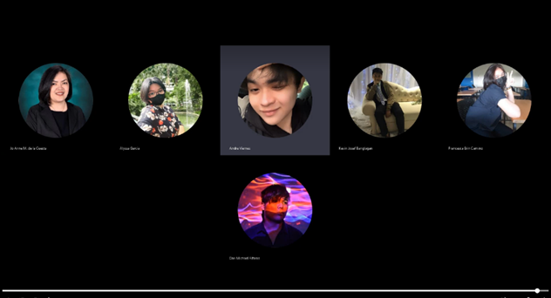

Project Consultation with Project Adviser | 30:41 minutes | September 23, 2022

* 1:00 – Checking of main aim in the paper
* 1:30 – Rephrasing statements that are more proper in the paper
* 2:28 – Checking of specific objectives
* 3:05 – Rephrasing statements per bullets
* 7:50 – Checking of technical background
* 9:30 – Discussing about the implementation of domain
* 15:24 – Discussing the implementation of payment system
* 21:59 – Checking of event table
* 29:35 – Summarization of corrections

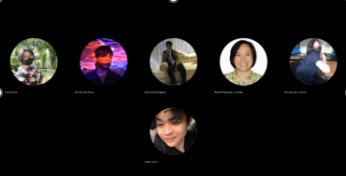

Project Consultation with Project Consultant | 24:4 minutes | September 23, 2022

* 1:08– Checking of main objective
* 1:20 – Removing subjective terms in the main objective
* 3:15 – Checking the specific objectives
* 8:47 – Checking of technical background
* 12:20 - Checking of event table
* 16:20 – Checking of diagrams

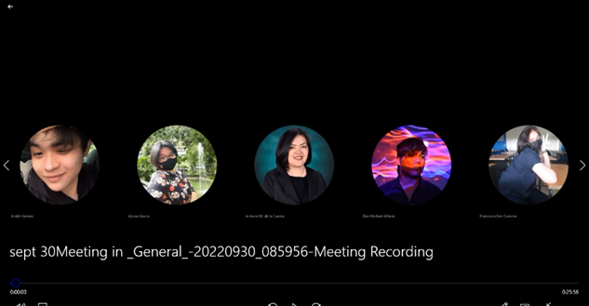

Update with Project Adviser | 25:58 minutes | September 30, 2022

* 1:08 – Consulting about the updated objectives
* 3:54 – Consulting about the updated technical background
* 5:47 – Checking the technicality of the project
* 9:24 – Rephrasing some statements in the technicality
* 13:12 – Checking grammar in the technicality
* 17:49 – Checking the features
* 19:16 – Checking the updated event table
* 21:41 – Planning for next meeting

**Finals**

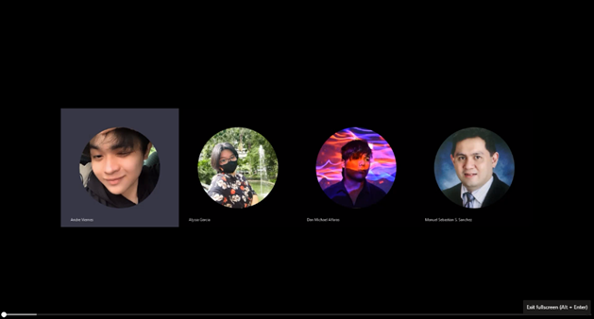

Consultation with Subject Adviser | 26:22 minutes | October 12, 2022

* 1:00 – Checking of sequence diagram
* 1:12 – The project adviser commenting on the sequence diagram
* 2:21 – Checking of package diagram
* 3:34 – The project adviser commented on the package diagram
* 7:28 – The subject adviser giving suggestions to state machine diagram
* 13:17 – Checking the deployment diagram
* 15:18 – The project adviser commenting on the deployment diagram
* 21:05 – Rechecking the sequence diagram
* 22:03 – The project adviser giving further suggestions to state machine diagram

Updating of all deliverables | 1:41:00 hour | October 18, 2022

* 4:10 – Dissemination of task
* 12:21 – Creating the comment matrix based on midterms
* 19:03 – Comparing the earlier paper to latest paper
* 27:54 – Updating the paper
* 52:23 – Updating the prototype
* 1:22:07 – Updating the PowerPoint presentation

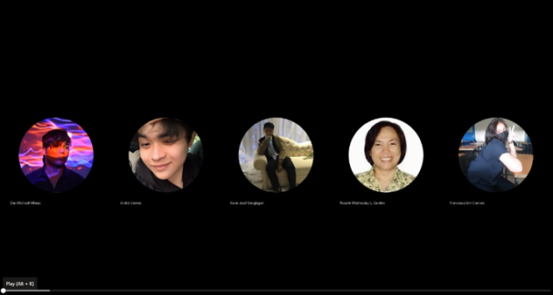

Project Consultation with Project Consultant | 40:11 minutes | October 25, 2022

* 1:11 – Discussing the SMART implementation in objectives
* 1:38 – Checking the updated aims based on the panel comments
* 4:51 – Removing some words in the objectives
* 10:16 – Checking the ERD diagram
* 15:45 – The project consultant suggested rewording the statistics to statistics
* 19:54 – Checking the class diagram
* 33:52 – Checking of data flow diagram
* 35:13 – Checking of Context flow diagram
* 38:06 – The project consultant suggested using the online library

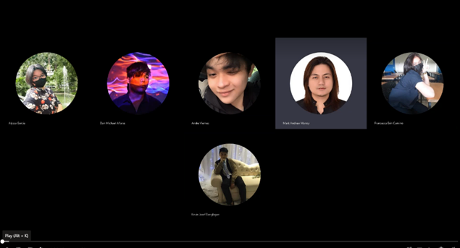

Project Review with Mr. Mark Andrew Manoy | 1:11:29 hours | October 25, 2022

* 2:07 – Checking the product backlog
* 04:33 – Discussion of fixing the prioritization in the product backlog
* 09:37 – Checking the updated specific objective
* 12:27 – Checking the updated ERD diagram
* 15:28 – Checking the RRL and its references
* 18:10 – Discussion of implementation of security in the web-app
* 18:54 – Discussion of scrum expert team
* 25:44 – Checking the ERD diagram
* 27:33 – Checking the part diagram
* 32:00 - Checking the package diagram
* 34:31 – Checking the state machine diagram
* 37:52 – Checking the sequence diagram
* 41:06 – Checking the prototype images (fill out form)
* 45:35 – Checking the prototype images (payment portal)
* 55:25 – Checking the grammar in the technicality
* 1:00:08 – Checking the data flow
* 1:03:29 – Rechecking the ERD

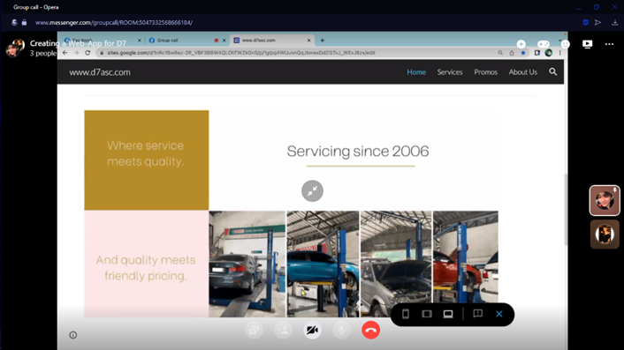

Meeting with client | 12:32 minutes | October 29, 2022

* 1:30 – The client requested to change the font of the web-app
* 3:01 – Discussion about the 360 virtual tour features
* 3:37 - Discussion about the payment
* 4:39 – The client said they have problems with the bank transfer
* 5:04 - The client agrees with the scan to pay system
* 6:12 – The client disagrees with the reservation fee
* 6:30 – The client agrees with the online logbook
* 7:04 – Discussion about the competitors
* 7:37 – Discussion about the branch locator feature
* 7:58 – Discussion about the contact information of the company
* 8:30 – Discussion about the edge features
* 9:26 – Discussion about the difference between websites and web-app
* 9:45 – Discussion how the web-app can view on mobile
* 11:37 – Inviting the client to join the presentation

## Appendix E: Source Code

<https://github.com/seans888/Elite-4>

